Sultanate of Oman
Ministry of Agriculture, Fisheries & Water Resources
Consultancy Services for Feasibility Study and Design of Flood Protection Scheme in North and South Al Batinah Governorates
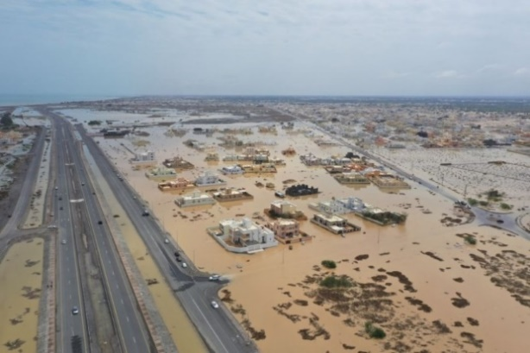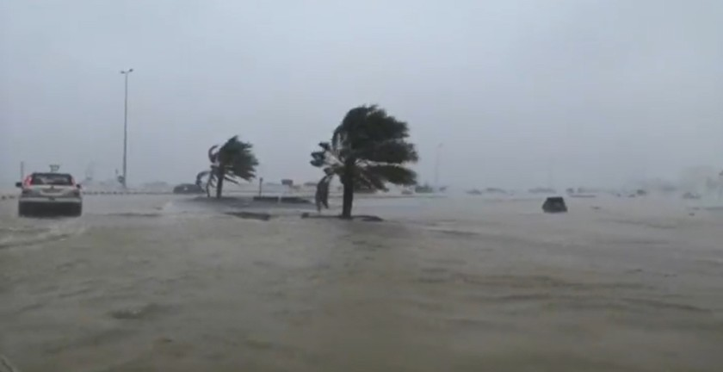
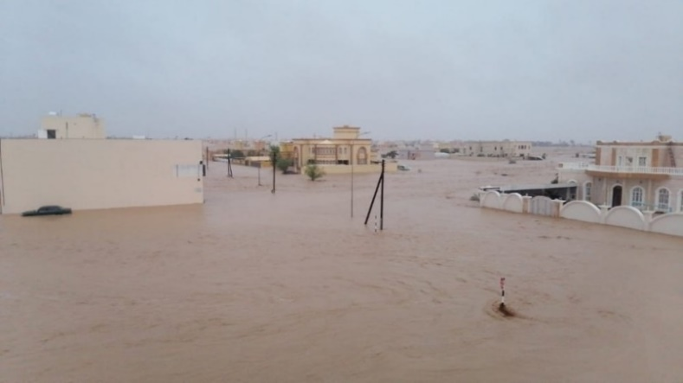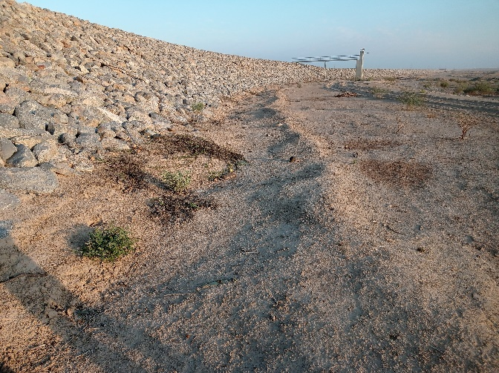
Hydraulic Design of Channels
Block No. 4
Rev 00
October 2026
Renardet S.A. & Partners Consulting Engineers L.L.C. | Artelia Muscat

Table of Contents
1. Introduction 1
1.1. Report Structure 2
2. Hydrology 3
2.1. Design rainfall 3
2.2. Area reduction factor 3
2.3. Curve number 4
2.4. The HEC-HMS model 5
3. The dams 8
3.1. Dams and catchments 8
3.2. Reservoir elevation-area-volume curves 10
3.3. Reservoir routing 11
3.4. Peak inflows and outflows 12
3.5. Reservoir levels 13
3.6. Hydrographs 14
3.7. Outfalls 15
4. Sediment yield and reservoir sedimentation 17
4.1. Soil loss of the catchments 17
4.2. Sediment delivery and yield 18
4.3. Reservoir volume reduction 27
5. Climate at the dam sites 30
5.1. Record used 30
5.2. Temperature and rainfall 30
5.3. Wind 32
5.4. Climate change 33
6. Channels 35
6.1. Alignments and design flows 35
6.2. Design criteria 35
6.3. Status 35
7. Conclusions 36
Appendix A – Inflow hydrographs of the dams 37
Appendix B – Reservoir curves after sedimentation 41
Appendix C – Digital deliverables 45

List of Tables
Table 1. Channel design process – Block 04 1
Table 2. Design rainfall depths, 24 hours 3
Table 3. Area reduction factor 4
Table 4. Dams' information 8
Table 5. Dam catchments 8
Table 6. Reservoir curves at full supply level and at crest 10
Table 7. Dams' peak inflow and outflow (m³/s) for the return periods 12
Table 8. Inflow and outflow volumes (Mm³) for selected return periods 13
Table 9. Peak reservoir level (m) for the return periods 13
Table 10. RUSLE factors and soil loss, catchment means 18
Table 11. Sediment delivery and yield of the dam catchments 19
Table 12. Reservoir volume reduction after 50 and 100 years 28
Table 13. Monthly temperature and rainfall at the dam sites, 2001–2023 30
Table 14. Mean annual rainfall of the dam catchments, SM2RAIN climatology 2007–2018 32
Table 15. Digital deliverables 45

List of Figures
Figure 1. The HEC-HMS model of Block 04 (Basin 3): subbasins, reaches, junctions, outfalls, dam sites and reservoirs. 6
Figure 2. The eight dams of Block 04, their catchments, the reservoirs at crest level and the channel and dyke alignments of the plain. 9
Figure 3. Elevation-capacity curves of the eight reservoirs; the dashed line is the full supply level, the dotted line the crest. 11
Figure 4. Peak inflow and routed peak outflow at the eight dams for the 100-, 200- and 1 000-year events. 12
Figure 5. Peak reservoir level above the full supply level for every return period; the crest lies 5 m above FSL at every dam. 13
Figure 6. Inflow and outflow hydrographs of the eight dams for the 200-year event. 15
Figure 7. 200-year peak flow at the thirteen outfalls without the dams (Basin 2) and with the dam reservoirs (Basin 3). 16
Figure 8. From soil loss to sediment yield: the catchment mean soil loss, the delivery ratio and the yield delivered to each dam. 19
Figure 9. Rainfall erosivity, the R factor, over the dam catchments. 20
Figure 10. Soil erodibility, the K factor, from the SoilGrids topsoil texture. 21
Figure 11. Slope length and steepness, the LS factor, from the 30 m DEM. 22
Figure 12. Cover management, the C factor, from the 2017 Landsat 8 vegetation index. 23
Figure 13. Support practice, the P factor, from the ESA WorldCover land cover. 24
Figure 14. Annual soil loss A = R K LS C P over the dam catchments. 25
Figure 15. Sediment yield delivered to each dam and the storage lost at full supply level in 50 years. 26
Figure 16. Storage lost at full supply level after 50 and 100 years, per dam. 28
Figure 17. Hawasinah 02: elevation-capacity and elevation-area curves before and after sedimentation. The curves of the other dams are in Appendix B. 29
Figure 18. Monthly temperature and rainfall at the Block 04 dams, 2001–2023 (NASA POWER, MERRA-2). 31
Figure 19. Annual rainfall at the dam sites, 2001–2023, and the mean of the record. 31
Figure 20. Wind rose at 10 m at the dam sites, all hours 2015–2024: the direction the wind blows from and the share of hours in each speed class. 32
Figure 21. Wind roses for all hours, the night, the summer and the winter. 33
Figure 22. Hawasinah 02: inflow hydrographs for the return periods of 2 to 10 000 years and the PMP. 37
Figure 23. Shafan 02: inflow hydrographs for the return periods of 2 to 10 000 years and the PMP. 37
Figure 24. Hawasinah EX: inflow hydrographs for the return periods of 2 to 10 000 years and the PMP. 38
Figure 25. Hawasinah 11: inflow hydrographs for the return periods of 2 to 10 000 years and the PMP. 38
Figure 26. Sarami 03: inflow hydrographs for the return periods of 2 to 10 000 years and the PMP. 39
Figure 27. Sarami 05: inflow hydrographs for the return periods of 2 to 10 000 years and the PMP. 39
Figure 28. Sakhin 08: inflow hydrographs for the return periods of 2 to 10 000 years and the PMP. 40
Figure 29. Sakhin 04: inflow hydrographs for the return periods of 2 to 10 000 years and the PMP. 40
Figure 30. Hawasinah 02: reservoir curves before and after sedimentation. 41
Figure 31. Shafan 02: reservoir curves before and after sedimentation. 41
Figure 32. Hawasinah EX: reservoir curves before and after sedimentation. 42
Figure 33. Hawasinah 11: reservoir curves before and after sedimentation. 42
Figure 34. Sarami 03: reservoir curves before and after sedimentation. 43
Figure 35. Sarami 05: reservoir curves before and after sedimentation. 43
Figure 36. Sakhin 08: reservoir curves before and after sedimentation. 44
Figure 37. Sakhin 04: reservoir curves before and after sedimentation. 44

Executive Summary
Project context
The Ministry of Agriculture, Fisheries Wealth and Water Resources commissioned Renardet S.A. & Partners Consulting Engineers, in joint venture with Artelia Muscat, to prepare the comprehensive master plan for flood protection dams, river training schemes and stormwater drainage in North and South Al Batinah. Block 04 covers the wadis of Al Hawasinah, Shafan, Sarami and Sakhin between the Hajar foothills and the coast. The scheme in Block 04 consists of eight flood-protection dams and a network of flood-protection channels, swales and dykes that carry the routed dam outflows and the runoff of the plain to the sea.
Scope of this revision
This revision reports the hydrology of Block 04 and the design information for the eight dams: catchments, inflow hydrographs for thirteen return periods up to the probable maximum precipitation, reservoir elevation-area-volume curves, reservoir routing, sediment yield and the storage lost to sedimentation, and the climate at the dam sites. The hydraulic design of the channels, which follows the Block 6 method, is reported in the next revision once the channel alignments are frozen.
Key findings

• The eight dams control 2,203 km² of catchment and hold 261 Mm³ at full supply level. The 200-year peak inflows range from 961 to 4,116 m³/s.

• Four reservoirs (Shafan 02, Sarami 03, Sarami 05, Sakhin 04) store the whole 200-year flood; Hawasinah 02, whose 11 Mm³ reservoir drains 420 km², attenuates the 200-year peak by 2 % only.

• At the probable maximum flood every reservoir rises 4.7 to 5.0 m above its full supply level, within the 5 m head the dam designs allow.

• The sediment yield of the catchments is 40 to 98 m³/km²/yr. Over 50 years seven reservoirs lose 1.1 to 4.1 % of their storage at full supply level; Hawasinah 02 loses 16 % in 50 years and 32 % in 100 years and needs a sediment management provision.

• The climate record at the dams gives a mean annual rainfall of 100 mm (2001–2023), a mean temperature of 28.5 °C, and a warming trend of 0.22 °C per decade; the prevailing wind is the north-easterly sea breeze.
Deliverables
The report is accompanied by the workbooks, shapefiles and KMZ files listed in Appendix C: the elevation-area-volume curves and the hydrographs of every dam, the peak flow and volume of every element of the HEC-HMS model for the thirteen return periods, the sediment yield and the revised reservoir curves after sedimentation, and the climate record.

Introduction
The study area covers the governorates of North and South Al Batinah in northern Oman. The full project title is “Consultancy Services for Study and Prepare Comprehensive Master Plan for Flood Protection Dams, River Training Schemes and Updating of Flood Maps and Stormwater Drainage System in North and South Al Batinah Governorates, Sultanate of Oman”. The master plan combines dams, dykes and stormwater channels to protect the urbanised areas, the industrial zones, the infrastructure and the planned developments of the plain from flood damage.
Block 04 lies between Al Khaburah and Saham. Its wadis rise in the Hajar foothills and cross a plain some 15 to 25 km wide before reaching the Gulf of Oman. Eight flood-protection dams are planned or exist at the foot of the hills: Hawasinah 02, Hawasinah 11 and the existing Hawasinah dam, Shafan 02, Sarami 03 and 05, Sakhin 04 and 08. The dam Shafan 08, considered in earlier work, is no longer part of the scheme. Downstream of the dams, flood-protection channels, swales and dykes take the routed outflows and the runoff of the plain to the sea.
All channels are designed with the upstream dams in place, since the dams attenuate the peak inflows, and the design target is the 200-year flood. The channel design process follows the stages used for Block 6, summarised in Table 1. This revision covers stages 1 to 3 and the dam information that stage 5 and the dam design team need; stages 4 to 7 follow in the next revision.
Table 1. Channel design process – Block 04
Stage | Title | Key components and methods | This revision
1 | Project input | Design rainfall, topography, land use, dam characteristics (height, reservoir, spillway) | Reported
2 | Catchment analysis | HEC-HMS subbasin delineation, area reduction factor, SCS curve number, lag time, reservoir and reach routing | Reported
3 | Rainfall-runoff simulation | Depth-area analyses for 2 to 10 000 years and the PMP; inflow and outflow hydrographs; reservoir levels | Reported
3a | Dam information | Elevation-area-volume curves, spillway rating, sediment yield, reservoir volume reduction, climate | Reported
4 | Channel alignment | HEC-RAS 2D results, wadi geometry, site visits, client and authority input | Next revision
5 | Hydraulic channel design | SewerGEMS: Manning, depth, slope, velocity, freeboard, culverts, constraints | Next revision
6 | Performance assessment | HEC-RAS: dyke heights, crossing capacity, outfalls, 200-year protection check | Next revision
7 | Outputs | Channel dimensions, dyke heights, crossing capacities, bottleneck solutions | Next revision

Report Structure
Section 2 presents the hydrology: the design rainfall, the area reduction factor, the curve number grid and the HEC-HMS model. Section 3 gives the dam information: catchments, reservoir curves, routing, peak flows and hydrographs. Section 4 estimates the sediment yield of the dam catchments and the storage the reservoirs lose to sedimentation. Section 5 describes the climate at the dam sites. Section 6 states the status of the channel design. The appendices carry the hydrographs of every dam, the revised reservoir curves and the list of digital deliverables.

Hydrology

Design rainfall
A nationwide hydrology analysis was carried out for the Ministry: the rainfall stations were screened, cleaned and tested for trends and outliers, the gaps were filled and the distributions fitted, and a regional frequency analysis gave the rainfall depth of each region. The 24-hour design depths and the temporal patterns of that study drive the rainfall-runoff model of Block 04, as they did for Block 6.
Table 2. Design rainfall depths, 24 hours
Return period (years) | Depth (mm)
2 | 27.6
5 | 55.3
10 | 105.5
25 | 137.5
50 | 168.1
100 | 205.4
200 | 251.0
500 | 327.2
1000 | 399.9
2000 | 488.7
5000 | 639.1
10000 | 685.1
PMP | PMP grid, 500 to 1 840 mm
The probable maximum precipitation follows the storm transposition and moisture maximisation method of the World Meteorological Organisation: the severest historical storms of the region are transposed to the catchment and their precipitable water is raised to its thermodynamic limit. The nationwide PMP grid supplies the 24-hour depth at each catchment. The dam spillways are sized for the probable maximum flood that results from it.

Area reduction factor
Point rainfall overstates the average depth over a large catchment, because an intense storm cell seldom covers the whole catchment at once. The area reduction factor of the nationwide study converts the point depth to the areal depth. HEC-HMS applies it through depth-area analyses: every element of the model is computed with the storm reduced for its own contributing area, so the peak at a dam site and the peak at a channel junction each carry the right reduction.
Table 3. Area reduction factor
Area (km²) | ARF
1 | 1.000
5 | 0.994
10 | 0.987
20 | 0.976
30 | 0.965
40 | 0.956
50 | 0.948
100 | 0.913
200 | 0.864
500 | 0.776
1000 | 0.694
2000 | 0.606

Curve number
The curve number grid combines the ESA WorldCover 2020 land cover at 10 m with the hydrologic soil groups derived from the ISRIC SoilGrids texture at 250 m through the SCS lookup table. The area-weighted curve numbers of the dam catchments lie between 87.7 (Sarami 05 and Sakhin 04) and 90.5 (Hawasinah 11). The initial abstraction and the lag time of each subbasin follow the SCS and Kirpich relations:
$I_{a} = 0.2 S, S = 25.4 \left(\frac{1000}{CN} - 10\right)$ (1)
$t_{lag} = 0.6 \frac{1}{52} L^{0.77} S^{-0.385}$ (2)
Ia: initial abstraction, mm
S: potential maximum retention, mm
CN: SCS curve number, –
t_lag: lag time, min
L: length of the 10–85 flow path, m
S: slope of the 10–85 flow path, m/m

The HEC-HMS model
The HEC-HMS 4.12 model of Block 04 is built in three basin models on the same terrain, the 10 m resampling of the 5 m national DEM. Basin 1 is the hydrology study's model of the dam catchments. Basin 2 keeps the dam catchments of Basin 1 unchanged and adds the catchments of the channel network, delineated on the terrain reconditioned with the channel alignments (burned) and the dykes and roads (raised): 110 subbasins, 115 reaches, 129 junctions and 13 outfalls to the sea. Basin 3 is Basin 2 with a reservoir element at each of the eight dams, 150 m downstream of the dam junction. Every basin runs the thirteen depth-area analyses, one per return period, with every element as an analysis point.
The elements carry the global catchment they belong to in their names: HAW for Al Hawasinah, SHA for Shafan, SAR for Sarami and SAK for Sakhin, followed by S for a subbasin, R for a reach, J for a junction and O for an outfall numbered west to east. The dam junctions keep the dam names. Reaches are routed by Muskingum-Cunge with a Manning n of 0.1, trapezoidal sections with side slopes of 1V:3H and a bottom width that carries the 200-year flow at 2 m depth; the natural wadi reaches of the plain take their section from the terrain.

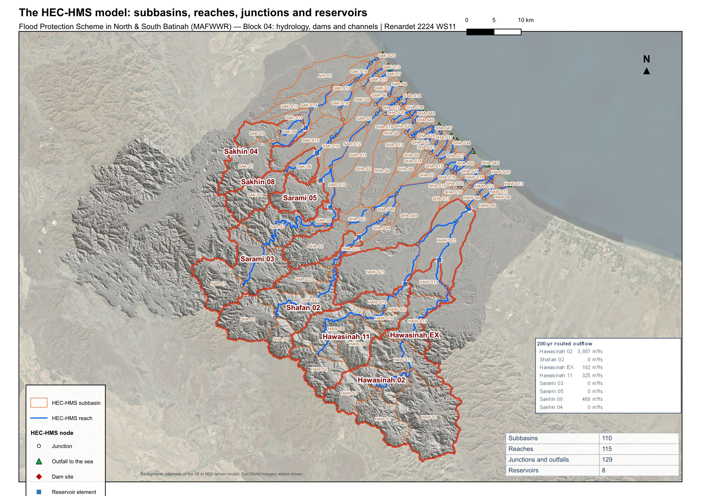
Figure 1. The HEC-HMS model of Block 04 (Basin 3): subbasins, reaches, junctions, outfalls, dam sites and reservoirs.

Basin 2 gives the undammed case, used to size the diversion and bypass works and to check the channels against the flows they would receive without the dams. Basin 3 gives the design case: the routed outflows of the reservoirs enter the channels. The peak flow and the volume of every element of both basins, for the thirteen return periods, are delivered in the workbooks and the shapefiles listed in Appendix C.

The dams

Dams and catchments
The eight dams sit at the foot of the hills where the wadis leave their gorges. Their characteristics, as fixed by the dam design team, are listed in Table 4: crest level, full supply level, reservoir capacity at full supply level, the probable maximum flood and the spillway length. Every spillway is a broad-crested weir with a discharge coefficient of 2.1 and a maximum head of 5 m at the probable maximum flood.
Table 4. Dams' information
Dam | Crest level (m) | FSL (m) | Height crest–bed (m) | Capacity at FSL (Mm³) | Spillway length (m) | QPMF (m³/s) | Dam length (m)
Hawasinah 02 | 149 | 144 | 19.5 | 11 | 759 | 17,809 | 3,159
Shafan 02 | 240 | 235 | 38.0 | 43 | 472 | 11,086 | 2,431
Hawasinah EX | 65 | 60 | 21.5 | 81 | 1,481 | 34,783 | 9,771
Hawasinah 11 | 256 | 251 | 40.0 | 34 | 501 | 11,767 | 947
Sarami 03 | 242 | 237 | 45.5 | 45 | 479 | 11,254 | 1,476
Sarami 05 | 189 | 184 | 26.0 | 15 | 166 | 3,888 | 2,540
Sakhin 08 | 144 | 139 | 17.5 | 8 | 209 | 4,912 | 2,048
Sakhin 04 | 127 | 122 | 25.0 | 24 | 315 | 7,393 | 2,768
The catchments of the dams are the catchments of the hydrology study, taken over unchanged into the Block 04 model (Table 5). Together they drain 2,203 km²; Hawasinah EX, the existing dam, drains the largest area, 859 km², which includes the catchments of Hawasinah 02 and 11 upstream of it. The weighted curve numbers reflect the bare, rocky mountain soils.
Table 5. Dam catchments
Dam | Catchment (km²) | Curve number | HMS subbasins | Longest flow path (km) | Relief (m)
Hawasinah 02 | 420 | 90.2 | 7 | 66.2 | 1,681
Shafan 02 | 224 | 90.2 | 5 | 49.8 | 1,291
Hawasinah EX | 859 | 89.4 | 15 | 79.7 | 1,766
Hawasinah 11 | 226 | 90.5 | 6 | 45.7 | 1,596
Sarami 03 | 228 | 90.1 | 4 | 57.1 | 1,311
Sarami 05 | 54 | 87.7 | 1 | 14.9 | 910
Sakhin 08 | 81 | 88.8 | 2 | 31.7 | 985
Sakhin 04 | 110 | 87.7 | 3 | 28.7 | 1,027

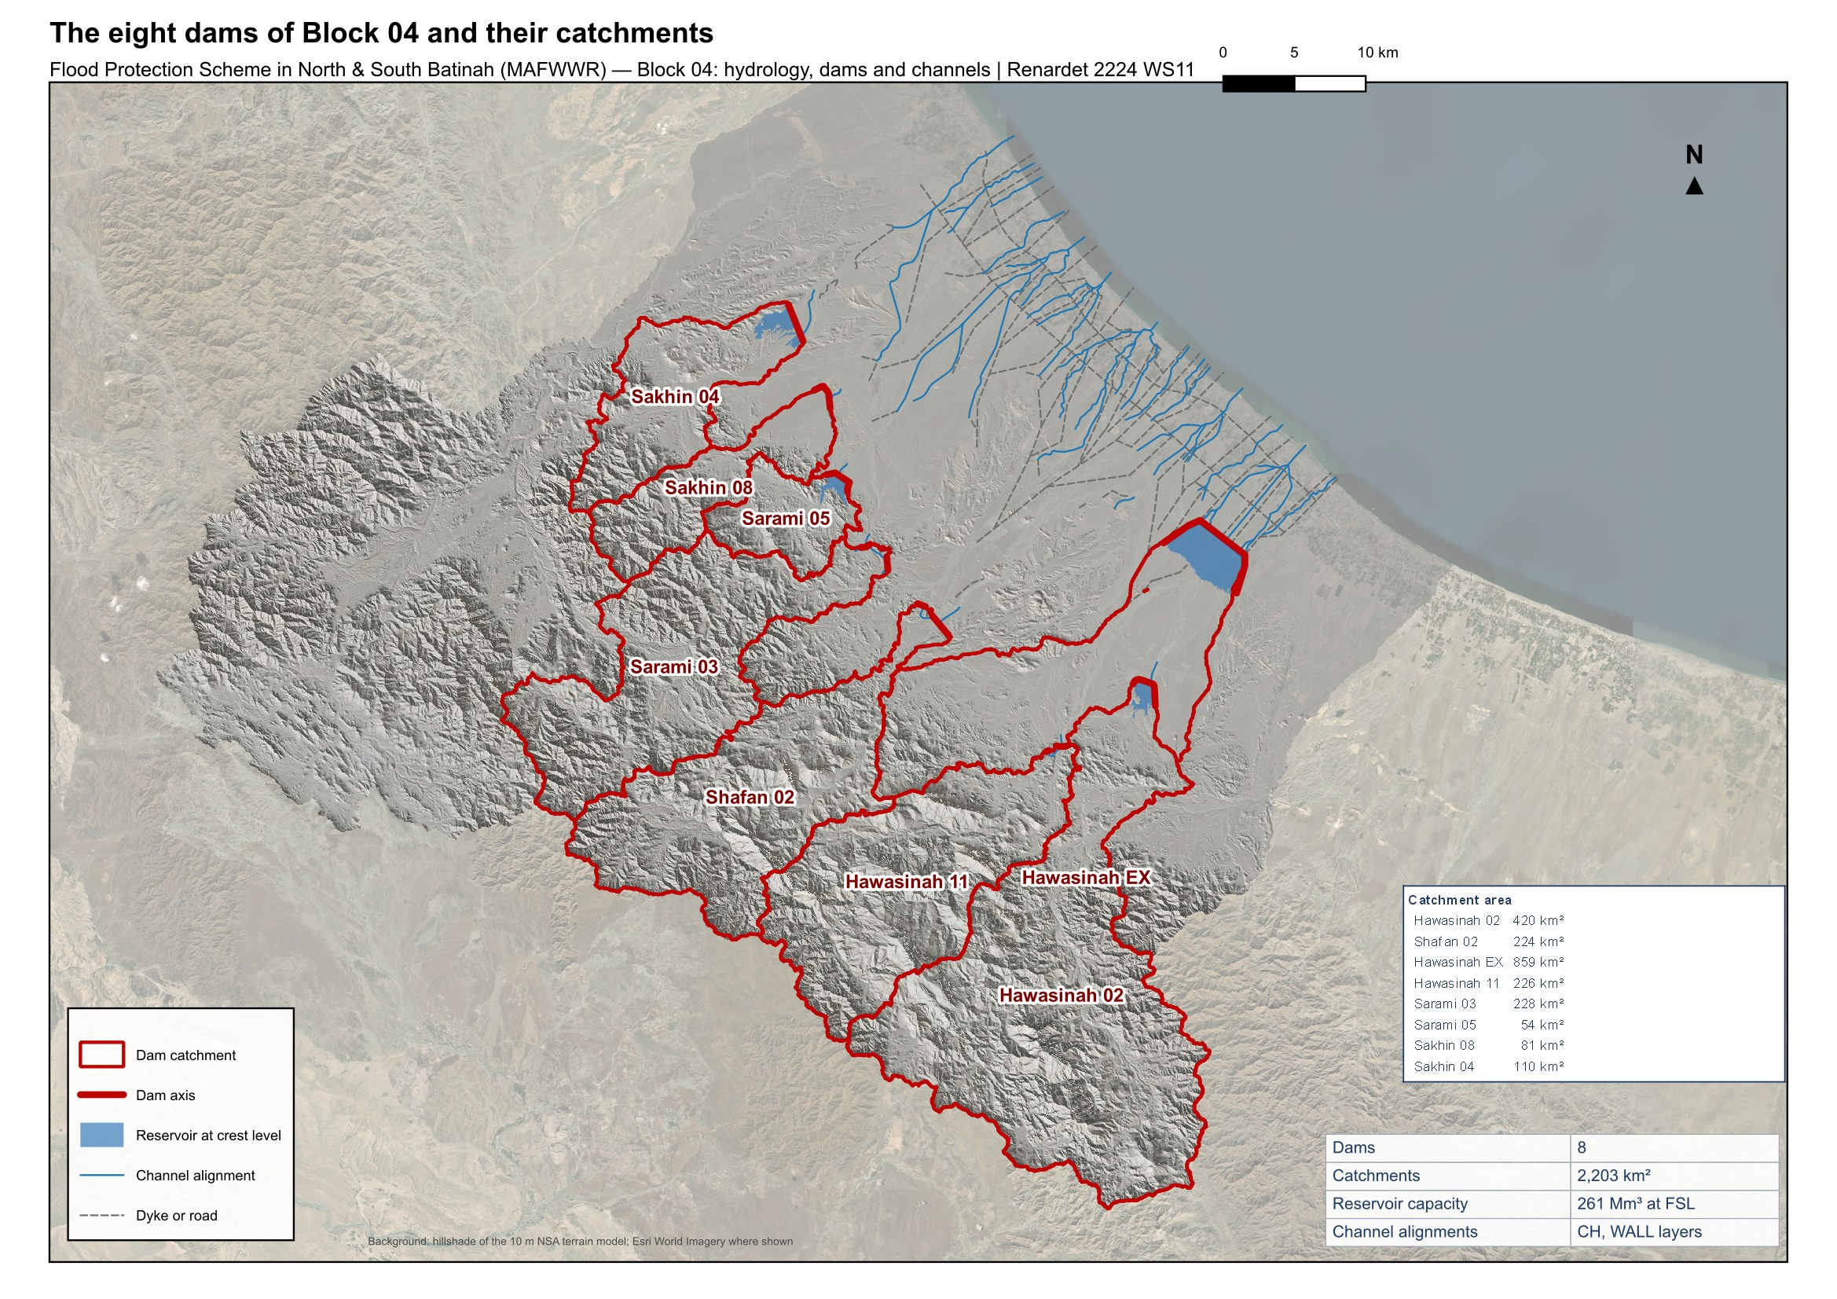
Figure 2. The eight dams of Block 04, their catchments, the reservoirs at crest level and the channel and dyke alignments of the plain.

Reservoir elevation-area-volume curves
The reservoir curves are measured on the 10 m terrain model inside the crest-level polygon of each dam: at every 0.5 m step from the wadi bed to the crest the flooded area is the set of cells below that level that connect to the dam axis, and the volume between steps follows the conic formula. The volumes at full supply level agree with the capacities of the dam design team to within 2 to 7 %, the terrain volumes being the lower (Table 6); the design team's capacities are kept as the reference and the curves are delivered in full in the workbook of Appendix C.
Table 6. Reservoir curves at full supply level and at crest
Dam | Bed (m) | Area at FSL (km²) | Volume at FSL (Mm³) | Capacity, dam team (Mm³) | Difference (%) | Area at crest (km²) | Volume at crest (Mm³)
Hawasinah 02 | 129.5 | 1.71 | 10.4 | 11 | -5.3 | 2.66 | 21.1
Shafan 02 | 202.0 | 3.62 | 41.6 | 43 | -3.2 | 4.51 | 61.9
Hawasinah EX | 43.5 | 10.77 | 79.2 | 81 | -2.2 | 14.71 | 142.8
Hawasinah 11 | 216.0 | 2.54 | 33.2 | 34 | -2.4 | 3.29 | 47.7
Sarami 03 | 196.5 | 3.64 | 42.7 | 45 | -5.1 | 4.43 | 63.0
Sarami 05 | 163.0 | 1.72 | 14.5 | 15 | -3.2 | 2.21 | 24.3
Sakhin 08 | 126.5 | 1.71 | 7.5 | 8 | -6.7 | 3.06 | 19.3
Sakhin 04 | 102.0 | 2.89 | 22.6 | 24 | -5.8 | 4.12 | 40.1
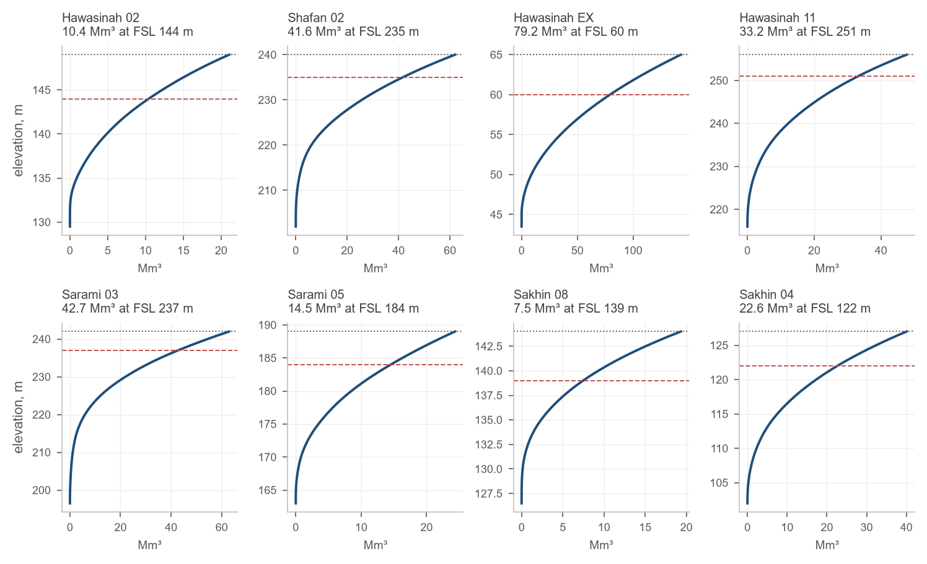
Figure 3. Elevation-capacity curves of the eight reservoirs; the dashed line is the full supply level, the dotted line the crest.

Reservoir routing
Each reservoir is routed by the Modified Puls method on its elevation-area curve. The outflow is the spillway discharge above full supply level, with the spillway length and coefficient of Table 4, and the flow over the dam crest once the level exceeds it:
$Q = C L H^{1.5} + 1.7 L_{crest} {\left(z - z_{crest}\right)}^{1.5}$ (3)
Q: outflow, m³/s
C: spillway discharge coefficient, 2.1, m^0.5/s
L: spillway length, m
H: head over the full supply level, m
L_crest: length of the dam crest, m
z: reservoir level, m
The reservoirs are empty at the start of every event. A low-level outlet is not modelled: it empties the reservoir between events and does not change the flood peak.

Peak inflows and outflows
Table 7 gives the peak inflow to each dam and the routed peak outflow for every return period; the inflow is the flow at the dam junction, the outflow the flow leaving the reservoir element. The inflows at the probable maximum precipitation reproduce the design floods of the dams sheet (Table 4).
Table 7. Dams' peak inflow and outflow (m³/s) for the return periods
Dam |  | 2 | 5 | 10 | 25 | 50 | 100 | 200 | 500 | 1000 | 2000 | 5000 | 10000 | PMP
Hawasinah 02 | In | 98 | 412 | 1,214 | 1,801 | 2,379 | 3,093 | 3,971 | 5,451 | 6,863 | 7,821 | 10,482 | 11,302 | 17,809
 | Out | 0 | 0 | 725 | 1,429 | 2,143 | 2,953 | 3,887 | 5,369 | 6,772 | 7,730 | 10,371 | 11,184 | 17,751
Shafan 02 | In | 86 | 319 | 913 | 1,348 | 1,773 | 2,283 | 2,890 | 3,888 | 4,830 | 5,416 | 7,170 | 7,705 | 11,086
 | Out | 0 | 0 | 0 | 0 | 0 | 0 | 0 | 528 | 1,398 | 2,485 | 4,755 | 5,447 | 10,556
Hawasinah EX | In | 23 | 122 | 568 | 1,237 | 1,975 | 2,938 | 4,116 | 6,030 | 7,750 | 10,002 | 16,583 | 18,259 | 34,879
 | Out | 0 | 0 | 0 | 0 | 0 | 0 | 182 | 1,663 | 3,802 | 6,543 | 12,119 | 13,890 | 33,239
Hawasinah 11 | In | 99 | 370 | 862 | 1,231 | 1,591 | 2,042 | 2,602 | 3,539 | 4,465 | 5,083 | 6,917 | 7,474 | 11,767
 | Out | 0 | 0 | 0 | 0 | 0 | 15 | 325 | 1,404 | 2,757 | 4,087 | 6,400 | 7,039 | 11,608
Sarami 03 | In | 77 | 347 | 954 | 1,359 | 1,763 | 2,259 | 2,857 | 3,853 | 4,796 | 5,379 | 7,125 | 7,655 | 11,254
 | Out | 0 | 0 | 0 | 0 | 0 | 0 | 0 | 485 | 1,314 | 2,378 | 4,632 | 5,328 | 10,732
Sarami 05 | In | 38 | 141 | 332 | 471 | 603 | 765 | 961 | 1,287 | 1,595 | 1,771 | 2,337 | 2,509 | 3,888
 | Out | 0 | 0 | 0 | 0 | 0 | 0 | 0 | 0 | 117 | 365 | 994 | 1,208 | 3,540
Sakhin 08 | In | 40 | 139 | 333 | 471 | 605 | 768 | 970 | 1,307 | 1,630 | 1,844 | 2,453 | 2,641 | 4,912
 | Out | 0 | 0 | 0 | 18 | 91 | 241 | 468 | 880 | 1,254 | 1,563 | 2,189 | 2,373 | 4,681
Sakhin 04 | In | 49 | 193 | 495 | 710 | 920 | 1,177 | 1,491 | 2,020 | 2,524 | 2,841 | 3,784 | 4,071 | 7,393
 | Out | 0 | 0 | 0 | 0 | 0 | 0 | 0 | 199 | 608 | 1,138 | 2,277 | 2,628 | 6,919
Four reservoirs store the whole 200-year flood: Shafan 02, Sarami 03, Sarami 05 and Sakhin 04 release nothing up to 200 years and Hawasinah EX and Hawasinah 11 release 182 and 325 m³/s against inflows of 4,116 and 2,602 m³/s. Sakhin 08 halves its 200-year peak. Hawasinah 02 is different: its reservoir holds 11 Mm³ against a 200-year inflow volume of 72 Mm³, so the spillway runs from the 10-year event and the 200-year peak passes almost unattenuated (3,887 m³/s). Its outflow is the largest flow the channels of Block 04 receive.
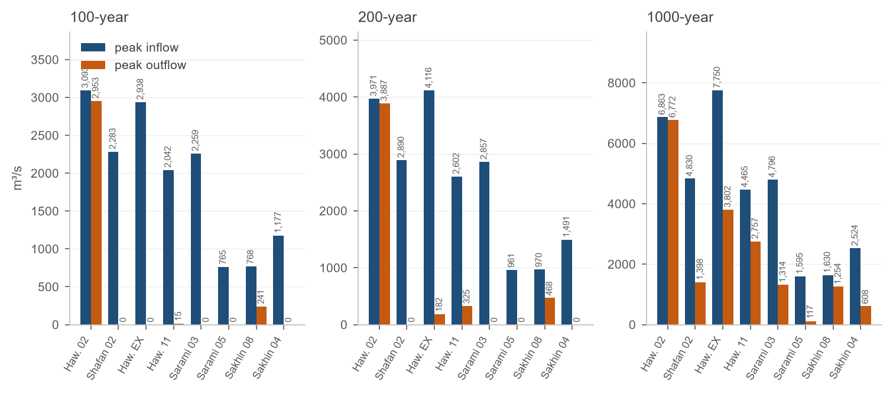
Figure 4. Peak inflow and routed peak outflow at the eight dams for the 100-, 200- and 1 000-year events.
Table 8. Inflow and outflow volumes (Mm³) for selected return periods
Dam | 10 in / out | 100 in / out | 200 in / out | 1000 in / out | PMP in / out
Hawasinah 02 | 24.5 / 14.1 | 56.6 / 46.2 | 71.6 / 61.2 | 121.0 / 110.6 | 365.4 / 355.0
Shafan 02 | 14.4 / 0.0 | 32.9 / 0.0 | 41.5 / 0.0 | 69.8 / 28.2 | 212.7 / 171.1
Hawasinah EX | 20.0 / 0.0 | 62.5 / 0.0 | 83.6 / 4.3 | 173.7 / 94.5 | 688.0 / 608.8
Hawasinah 11 | 14.7 / 0.0 | 33.3 / 0.2 | 42.0 / 8.9 | 70.6 / 37.4 | 217.7 / 184.5
Sarami 03 | 14.5 / 0.0 | 33.3 / 0.0 | 42.0 / 0.0 | 70.7 / 28.0 | 218.5 / 175.8
Sarami 05 | 3.6 / 0.0 | 8.4 / 0.0 | 10.7 / 0.0 | 18.2 / 3.6 | 67.7 / 53.2
Sakhin 08 | 5.5 / 0.0 | 12.7 / 5.3 | 16.1 / 8.6 | 27.2 / 19.7 | 97.3 / 89.8
Sakhin 04 | 7.0 / 0.0 | 16.5 / 0.0 | 21.0 / 0.0 | 35.7 / 13.1 | 138.0 / 115.4

Reservoir levels
The peak reservoir level of every event is listed in Table 9 and drawn against the full supply level in Figure 5. At the probable maximum flood the reservoirs reach 4.7 to 5.0 m above full supply level, within the 5 m head the spillways are designed for; the dam design team's rating is confirmed by the routing.
Table 9. Peak reservoir level (m) for the return periods
Dam | FSL | 2 | 5 | 10 | 25 | 50 | 100 | 200 | 500 | 1000 | 2000 | 5000 | 10000 | PMP
Hawasinah 02 | 144 | 137.7 | 143.5 | 144.6 | 144.9 | 145.2 | 145.5 | 145.8 | 146.2 | 146.6 | 146.9 | 147.5 | 147.7 | 149.0
Shafan 02 | 235 | 213.7 | 219.7 | 225.3 | 227.9 | 230.1 | 232.4 | 235.0 | 235.6 | 236.2 | 236.8 | 237.8 | 238.1 | 239.8
Hawasinah EX | 60 | 46.2 | 47.9 | 52.6 | 54.8 | 56.5 | 58.3 | 60.1 | 60.6 | 61.1 | 61.6 | 62.5 | 62.7 | 64.8
Hawasinah 11 | 251 | 227.1 | 234.2 | 241.7 | 245.2 | 248.1 | 251.0 | 251.4 | 252.2 | 252.9 | 253.5 | 254.3 | 254.5 | 256.0
Sarami 03 | 237 | 212.3 | 219.8 | 226.5 | 229.4 | 231.7 | 234.2 | 236.8 | 237.6 | 238.2 | 238.8 | 239.8 | 240.0 | 241.8
Sarami 05 | 184 | 168.1 | 171.5 | 175.2 | 176.9 | 178.4 | 179.9 | 181.6 | 184.0 | 184.5 | 185.0 | 186.0 | 186.3 | 188.7
Sakhin 08 | 139 | 132.0 | 134.7 | 137.7 | 139.1 | 139.3 | 139.7 | 140.0 | 140.6 | 141.0 | 141.3 | 141.9 | 142.1 | 143.8
Sakhin 04 | 122 | 106.7 | 110.5 | 114.7 | 116.5 | 118.1 | 119.7 | 121.4 | 122.4 | 122.9 | 123.4 | 124.3 | 124.5 | 126.8
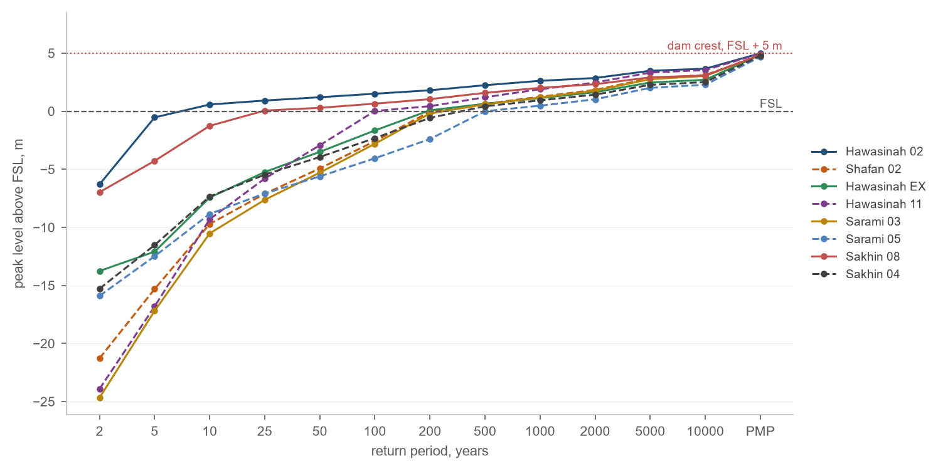
Figure 5. Peak reservoir level above the full supply level for every return period; the crest lies 5 m above FSL at every dam.

Hydrographs
Figure 6 shows the 200-year inflow and outflow hydrographs of the eight dams on one page. The area between the two curves is the volume the reservoir stores; the delay of the outflow peak and its reduction measure the dam's performance. The inflow hydrographs of all thirteen return periods are given for every dam in Appendix A, and the 5-minute series of every dam and return period in the hydrograph workbook.
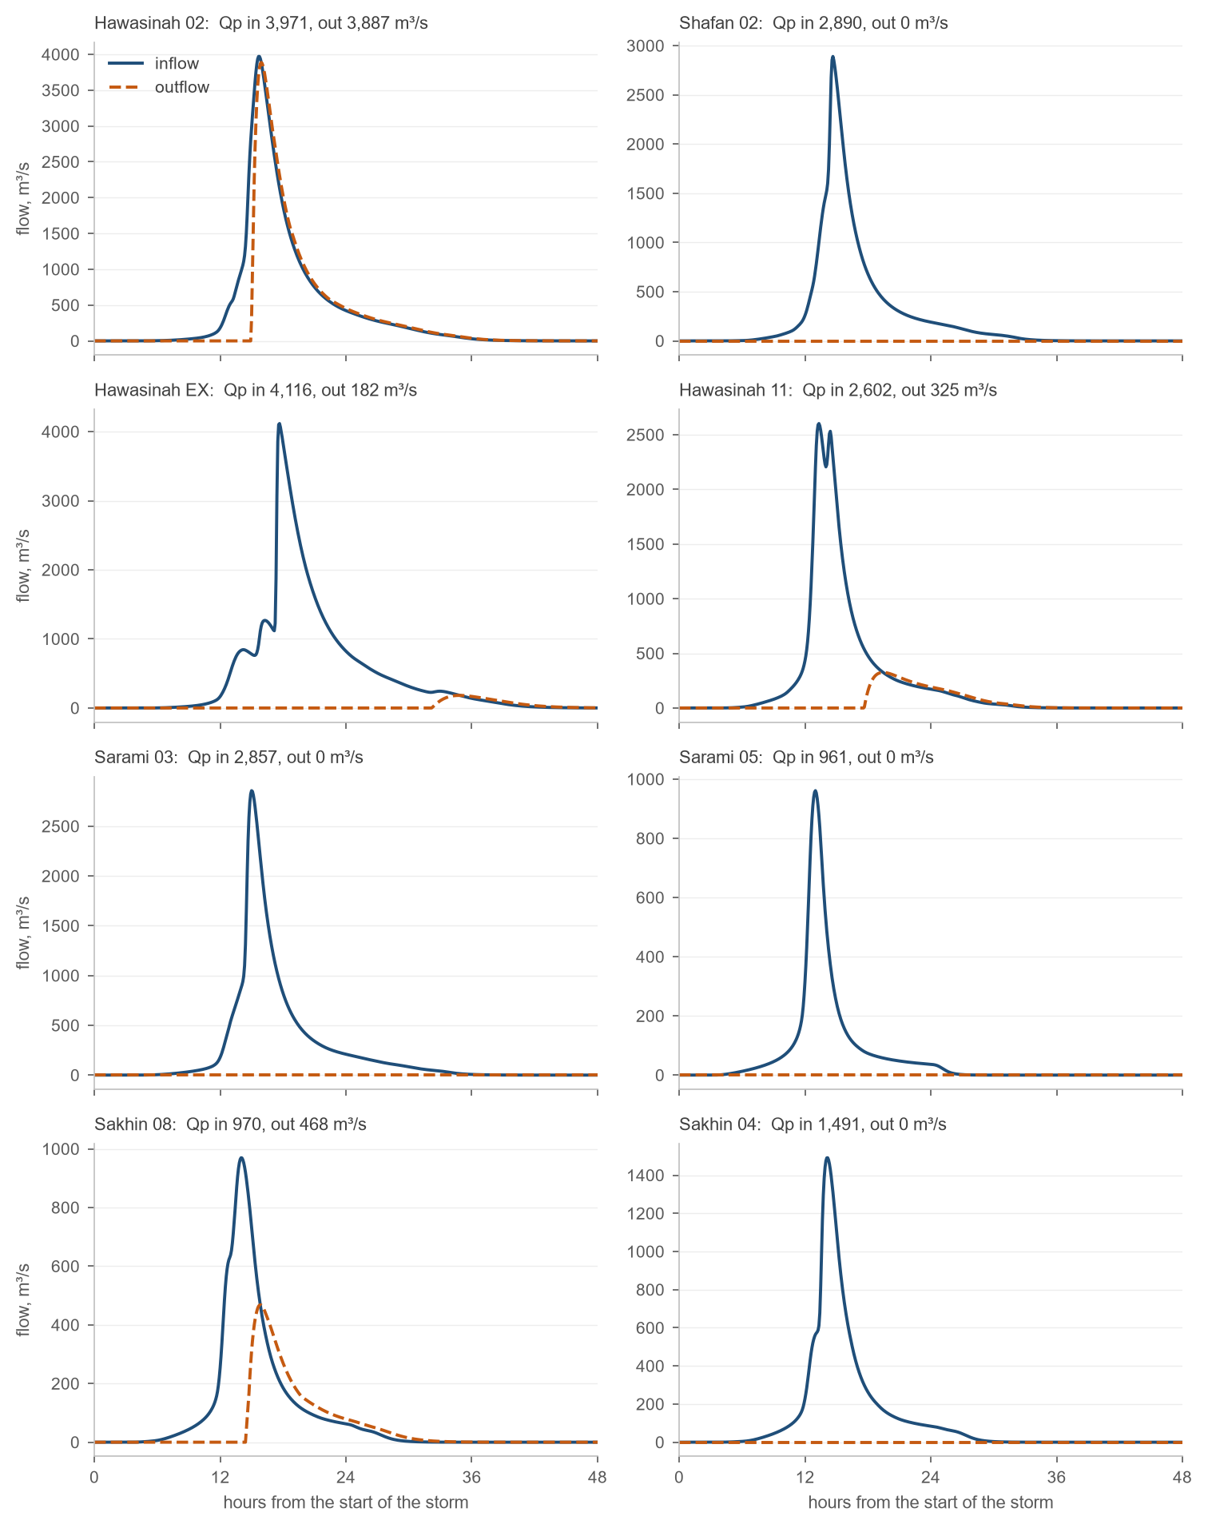
Figure 6. Inflow and outflow hydrographs of the eight dams for the 200-year event.

Outfalls
The thirteen outfalls of the channel network to the sea receive, in the 200-year event, between 57 and 1,404 m³/s with the reservoirs in operation. Without the dams the three largest outfalls would carry 4,492, 2,476 and 2,428 m³/s; the reservoirs cut them to 217, 1,022 and 1,404 m³/s. The outfalls fed by the plain alone are unchanged.
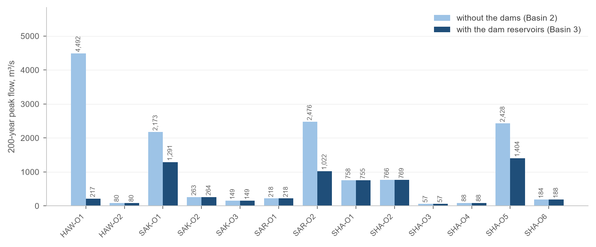
Figure 7. 200-year peak flow at the thirteen outfalls without the dams (Basin 2) and with the dam reservoirs (Basin 3).

Sediment yield and reservoir sedimentation

Soil loss of the catchments
The soil loss of each catchment is estimated with the Revised Universal Soil Loss Equation on a 250 m grid, from public remote-sensing data, with the same pipeline as the Block 6 dams:
$A = R K LS C P$ (4)
A: mean annual soil loss, t/ha/yr
R: rainfall erosivity, MJ mm/(ha h yr)
K: soil erodibility, t ha h/(ha MJ mm)
LS: slope length and steepness factor, –
C: cover management factor, –
P: support practice factor, –
The rainfall erosivity comes from the mean monthly precipitation of the SM2RAIN climatology at 1 km, the soil erodibility from the sand, silt and clay fractions of the SoilGrids topsoil by the Williams relation, the slope factor from the Copernicus 30 m DEM and its D8 flow accumulation by Moore and Burch, the cover factor from the vegetation index of a Landsat 8 mosaic of 2017, and the practice factor from the ESA WorldCover land cover:
$R = 1.73 × {10}^{1.5 \left(\log{P_{m}} - 0.08188\right)}$ (5)
$LS = 1.4 {\left(\frac{FA · 30}{22.13}\right)}^{0.4} {\left(\frac{\sin{θ}}{0.0896}\right)}^{1.3}, C = 0.1 \frac{1 - NDVI}{2}$ (6)
P_m: mean monthly precipitation, mm
FA: flow accumulation, cells of 30 m, capped at 300, –
θ: slope angle, capped at 30°, °
NDVI: normalised difference vegetation index, –
The catchment means of the factors and of the soil loss are listed in Table 10 and mapped in Figures 8 to 13. The soil loss runs from 6.3 t/ha/yr (Sakhin 04) to 13.9 t/ha/yr (Hawasinah 11); the steep mountain catchments of Hawasinah 11, Shafan 02 and Sarami 03 carry the highest erosivity and slope factors, the plain catchments of Sakhin 04 and Sarami 05 the lowest.
Table 10. RUSLE factors and soil loss, catchment means
Dam | R | K | LS | C | P | Soil loss A (t/ha/yr)
Hawasinah 02 | 52.4 | 0.229 | 19.9 | 0.0467 | 0.998 | 11.8
Shafan 02 | 56.9 | 0.228 | 21.4 | 0.0467 | 0.998 | 13.5
Hawasinah EX | 48.6 | 0.227 | 16.8 | 0.0468 | 0.999 | 10.0
Hawasinah 11 | 56.1 | 0.230 | 22.0 | 0.0467 | 0.999 | 13.9
Sarami 03 | 58.6 | 0.229 | 20.7 | 0.0464 | 0.995 | 13.2
Sarami 05 | 43.4 | 0.223 | 12.9 | 0.0479 | 0.999 | 6.3
Sakhin 08 | 49.4 | 0.228 | 16.1 | 0.0472 | 0.998 | 9.7
Sakhin 04 | 43.9 | 0.225 | 12.2 | 0.0468 | 0.999 | 6.3

Sediment delivery and yield
Only part of the eroded soil reaches the dam; the rest settles on the way. The sediment delivery ratio follows Williams (1977), as in the Block 6 report, from the catchment area, its relief ratio and its curve number; the relief ratio is the relief of the catchment on the 10 m terrain divided by the longest flow path to the dam:
$SDR = 1.366 × {10}^{-11} A^{-0.1} {RR}^{0.363} {CN}^{5.444}$ (7)
SDR: sediment delivery ratio, –
A: catchment area, km²
RR: relief ratio, relief / longest flow path, –
CN: area-weighted curve number, –
Table 11. Sediment delivery and yield of the dam catchments
Dam | Area (km²) | Relief (m) | Flow path (km) | Relief ratio | CN | SDR | Yield (m³/km²/yr) | Yield (1 000 m³/yr)
Hawasinah 02 | 420 | 1,681 | 66.2 | 0.0254 | 90.2 | 0.087 | 68 | 29
Shafan 02 | 224 | 1,291 | 49.8 | 0.0259 | 90.2 | 0.093 | 83 | 19
Hawasinah EX | 859 | 1,766 | 79.7 | 0.0222 | 89.4 | 0.073 | 49 | 42
Hawasinah 11 | 226 | 1,596 | 45.7 | 0.0349 | 90.5 | 0.105 | 98 | 22
Sarami 03 | 228 | 1,311 | 57.1 | 0.0230 | 90.1 | 0.088 | 78 | 18
Sarami 05 | 54 | 910 | 14.9 | 0.0609 | 87.7 | 0.126 | 53 | 3
Sakhin 08 | 81 | 985 | 31.7 | 0.0311 | 88.8 | 0.101 | 65 | 5
Sakhin 04 | 110 | 1,027 | 28.7 | 0.0357 | 87.7 | 0.096 | 40 | 4
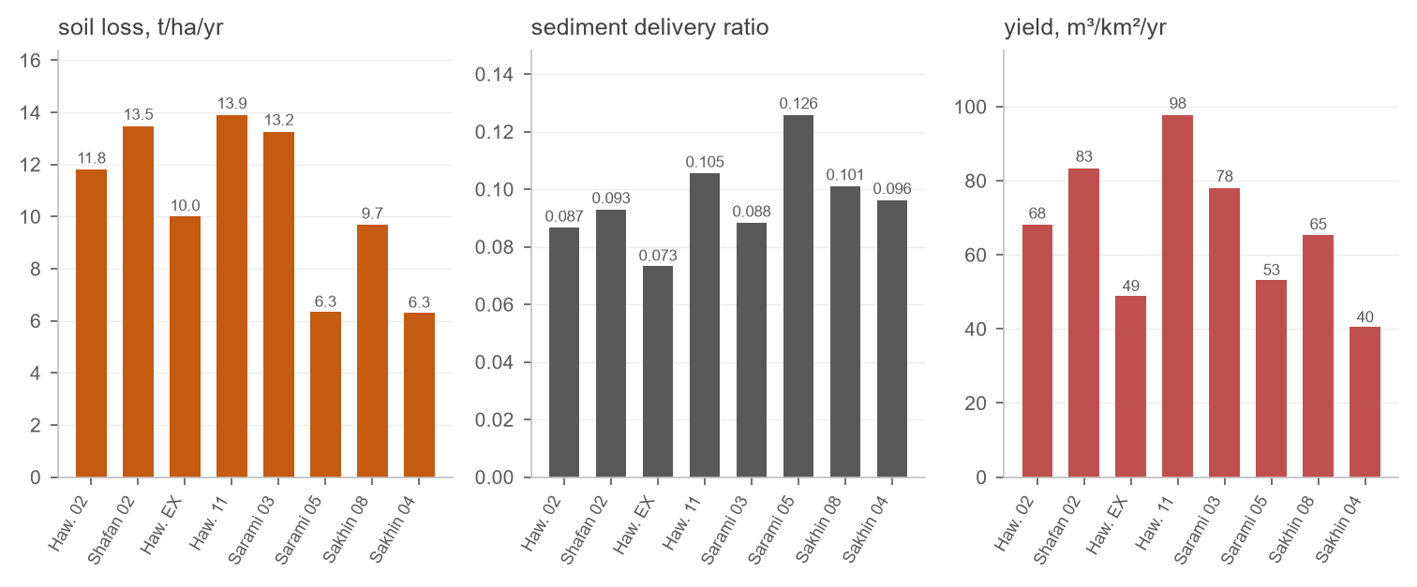
Figure 8. From soil loss to sediment yield: the catchment mean soil loss, the delivery ratio and the yield delivered to each dam.
The yields lie between 40 and 98 m³/km²/yr, in the range of the Block 6 catchments and below the 122 m³/km²/yr adopted for Wadi Majlas. The highest yield, at Hawasinah 11, combines the steepest catchment with the highest curve number.

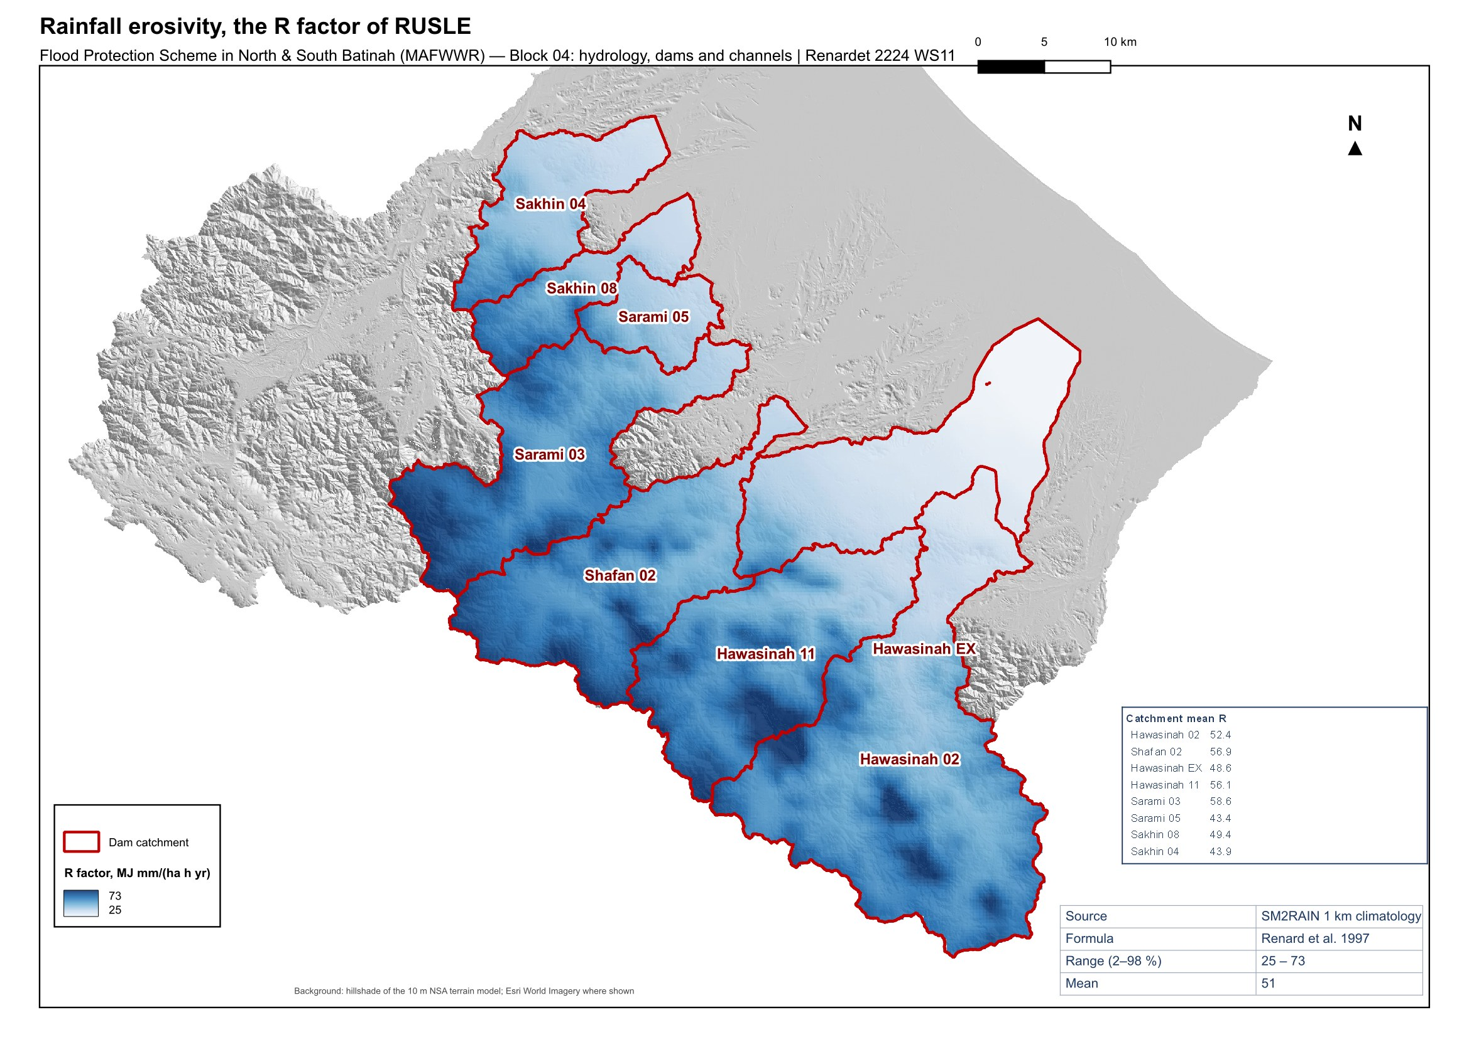
Figure 9. Rainfall erosivity, the R factor, over the dam catchments.

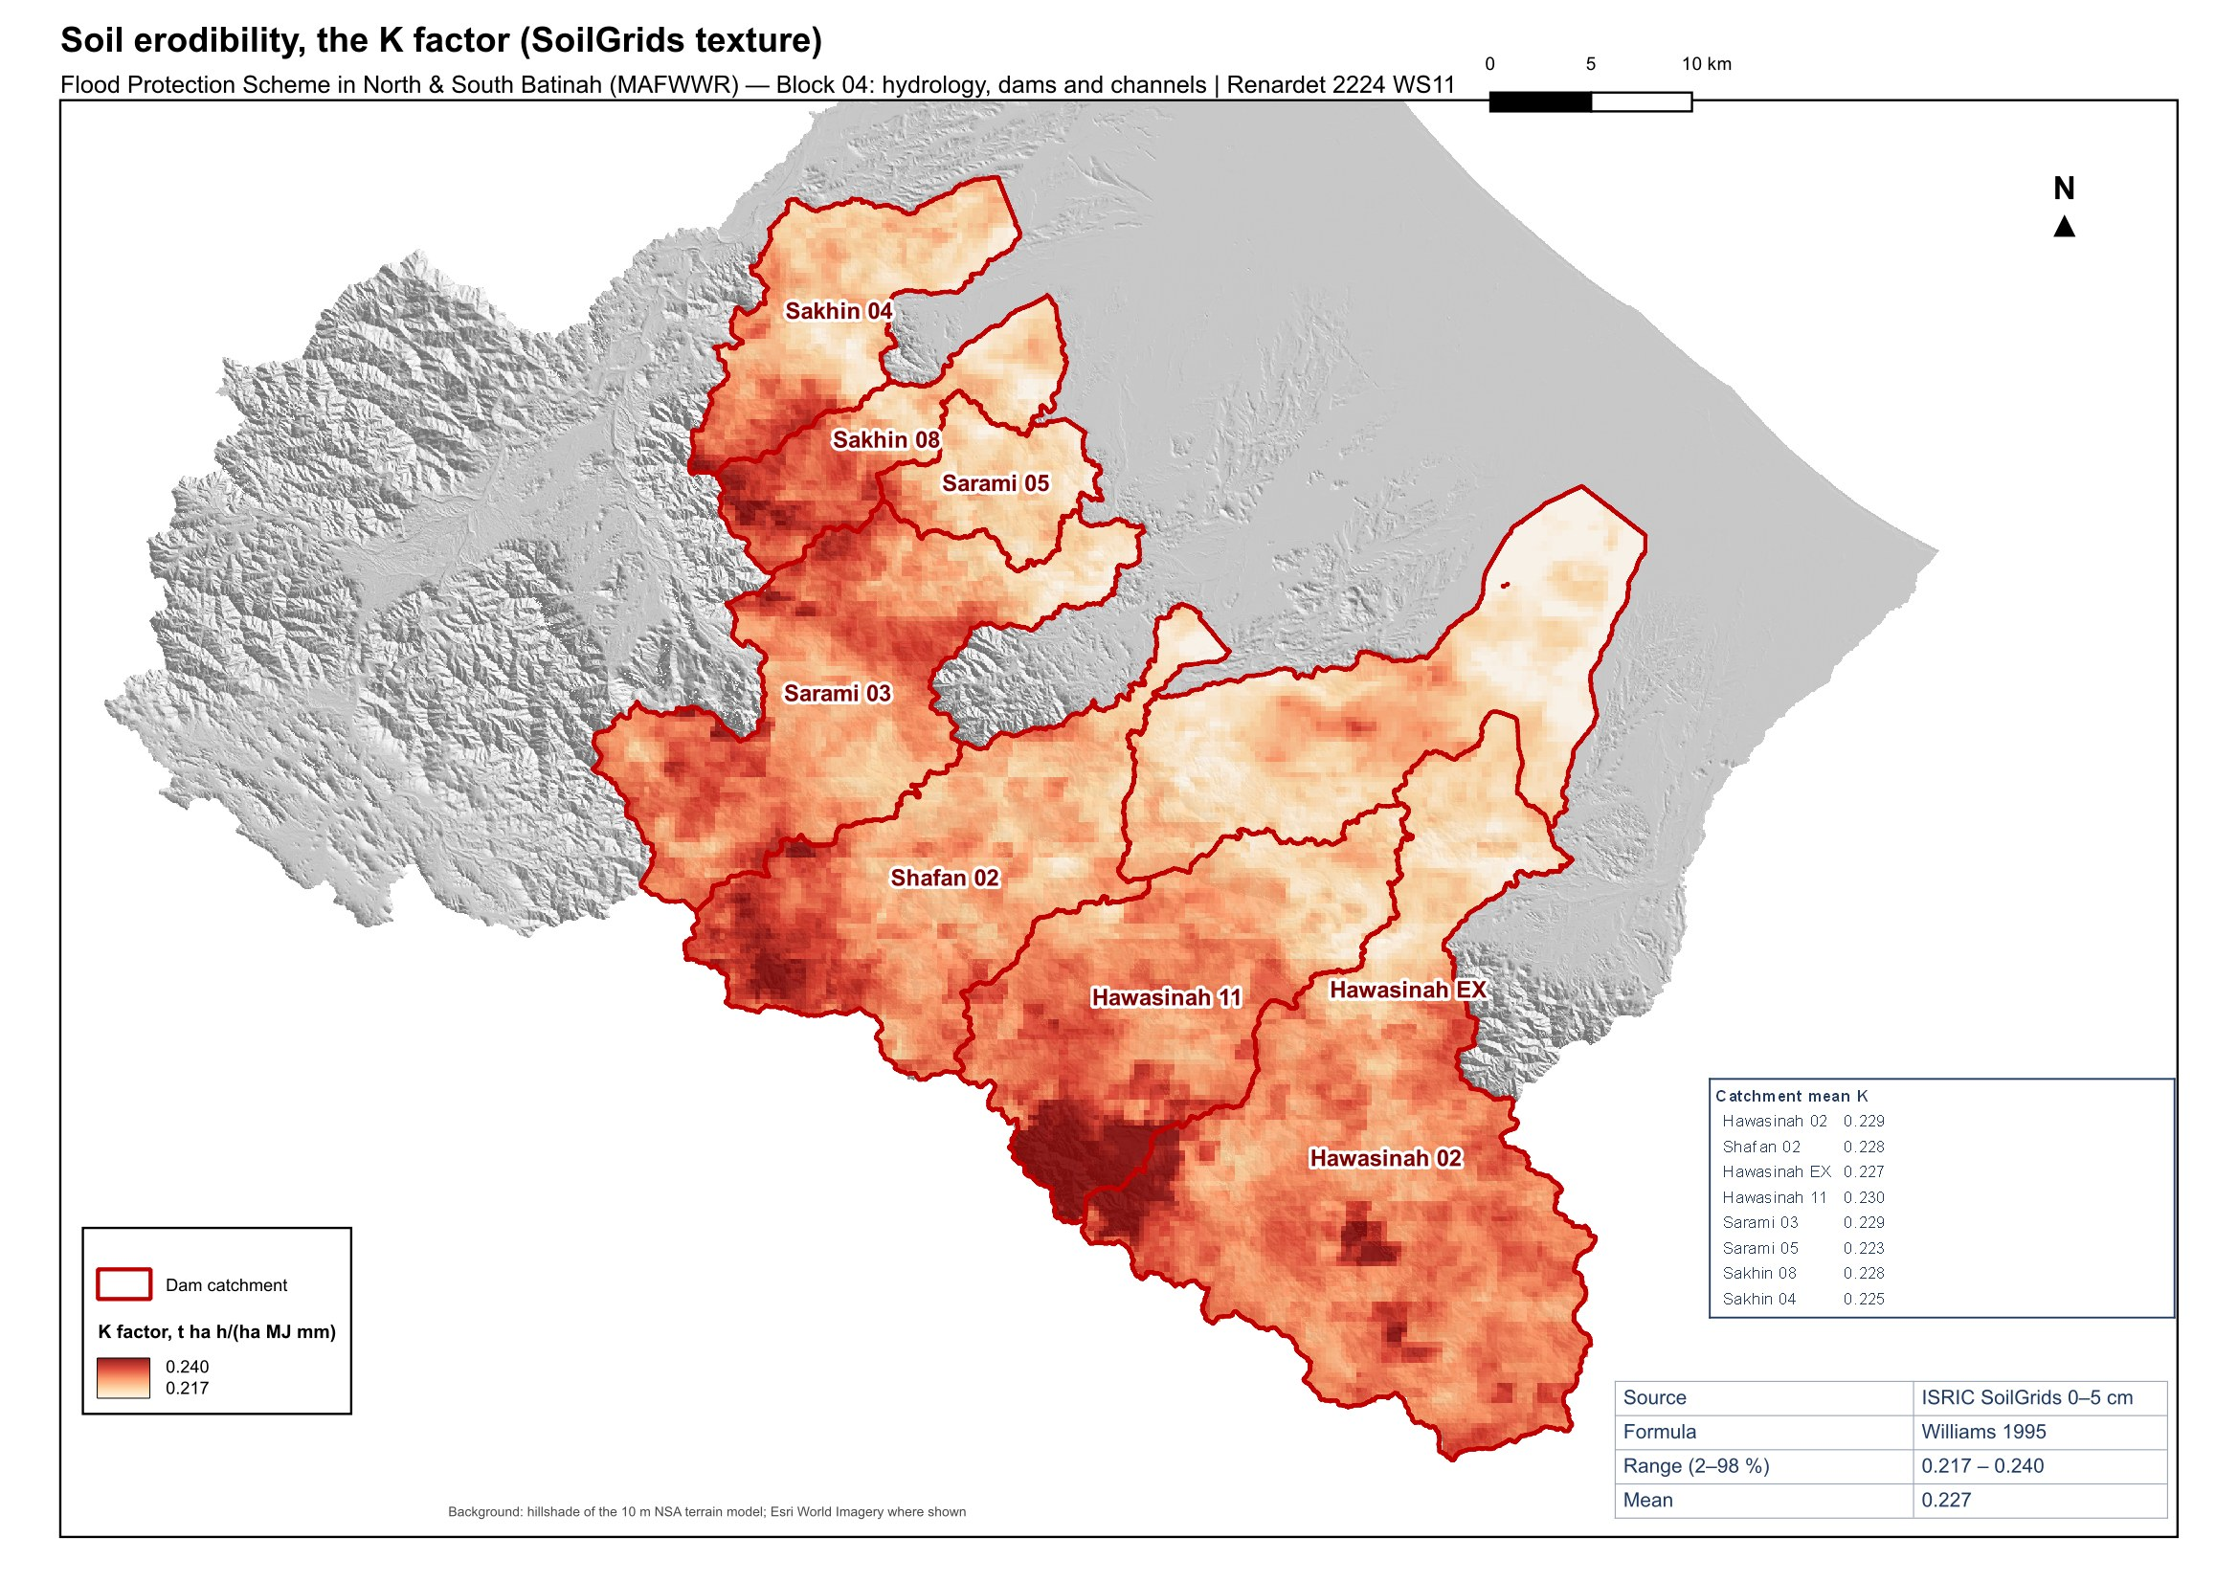
Figure 10. Soil erodibility, the K factor, from the SoilGrids topsoil texture.

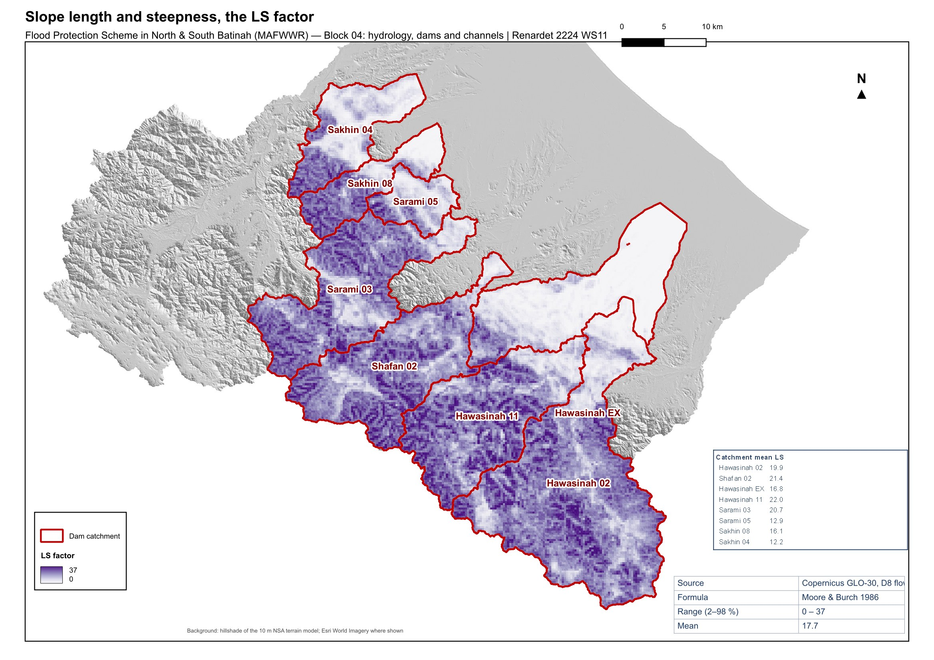
Figure 11. Slope length and steepness, the LS factor, from the 30 m DEM.

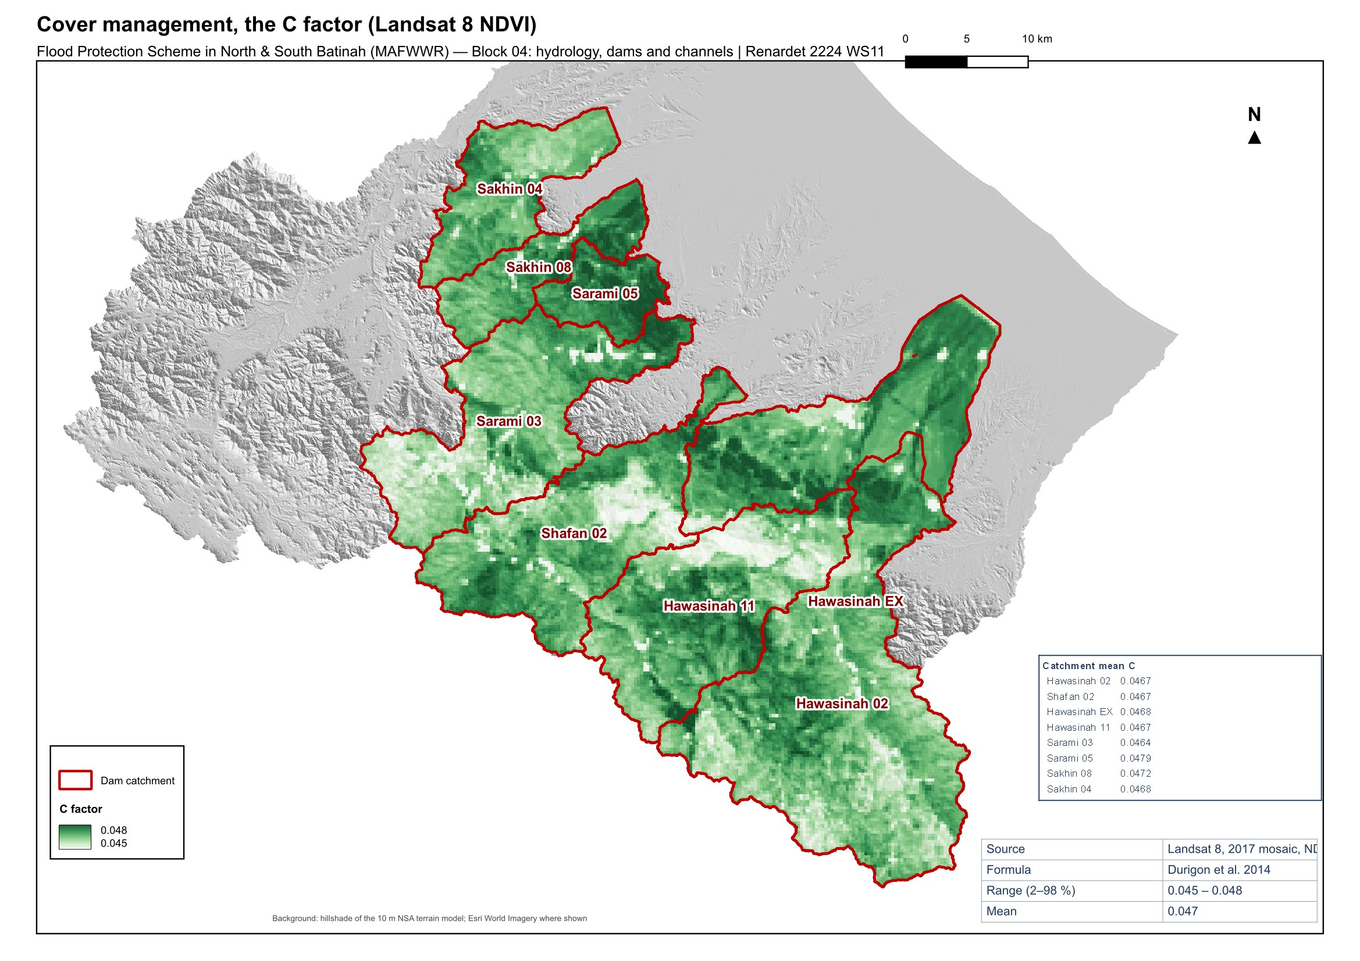
Figure 12. Cover management, the C factor, from the 2017 Landsat 8 vegetation index.

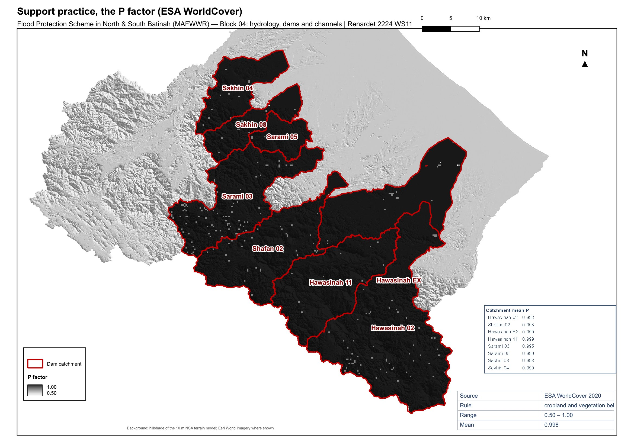
Figure 13. Support practice, the P factor, from the ESA WorldCover land cover.

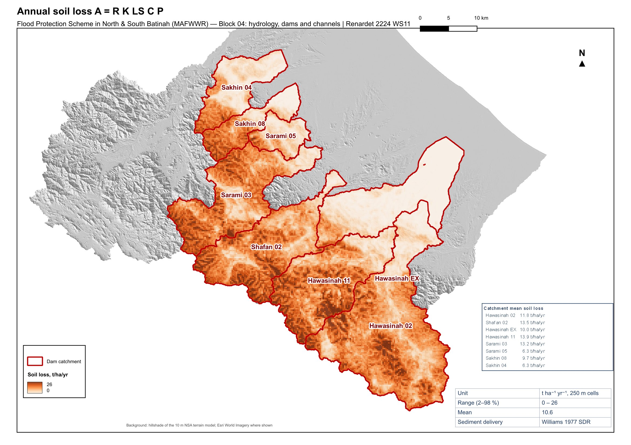
Figure 14. Annual soil loss A = R K LS C P over the dam catchments.

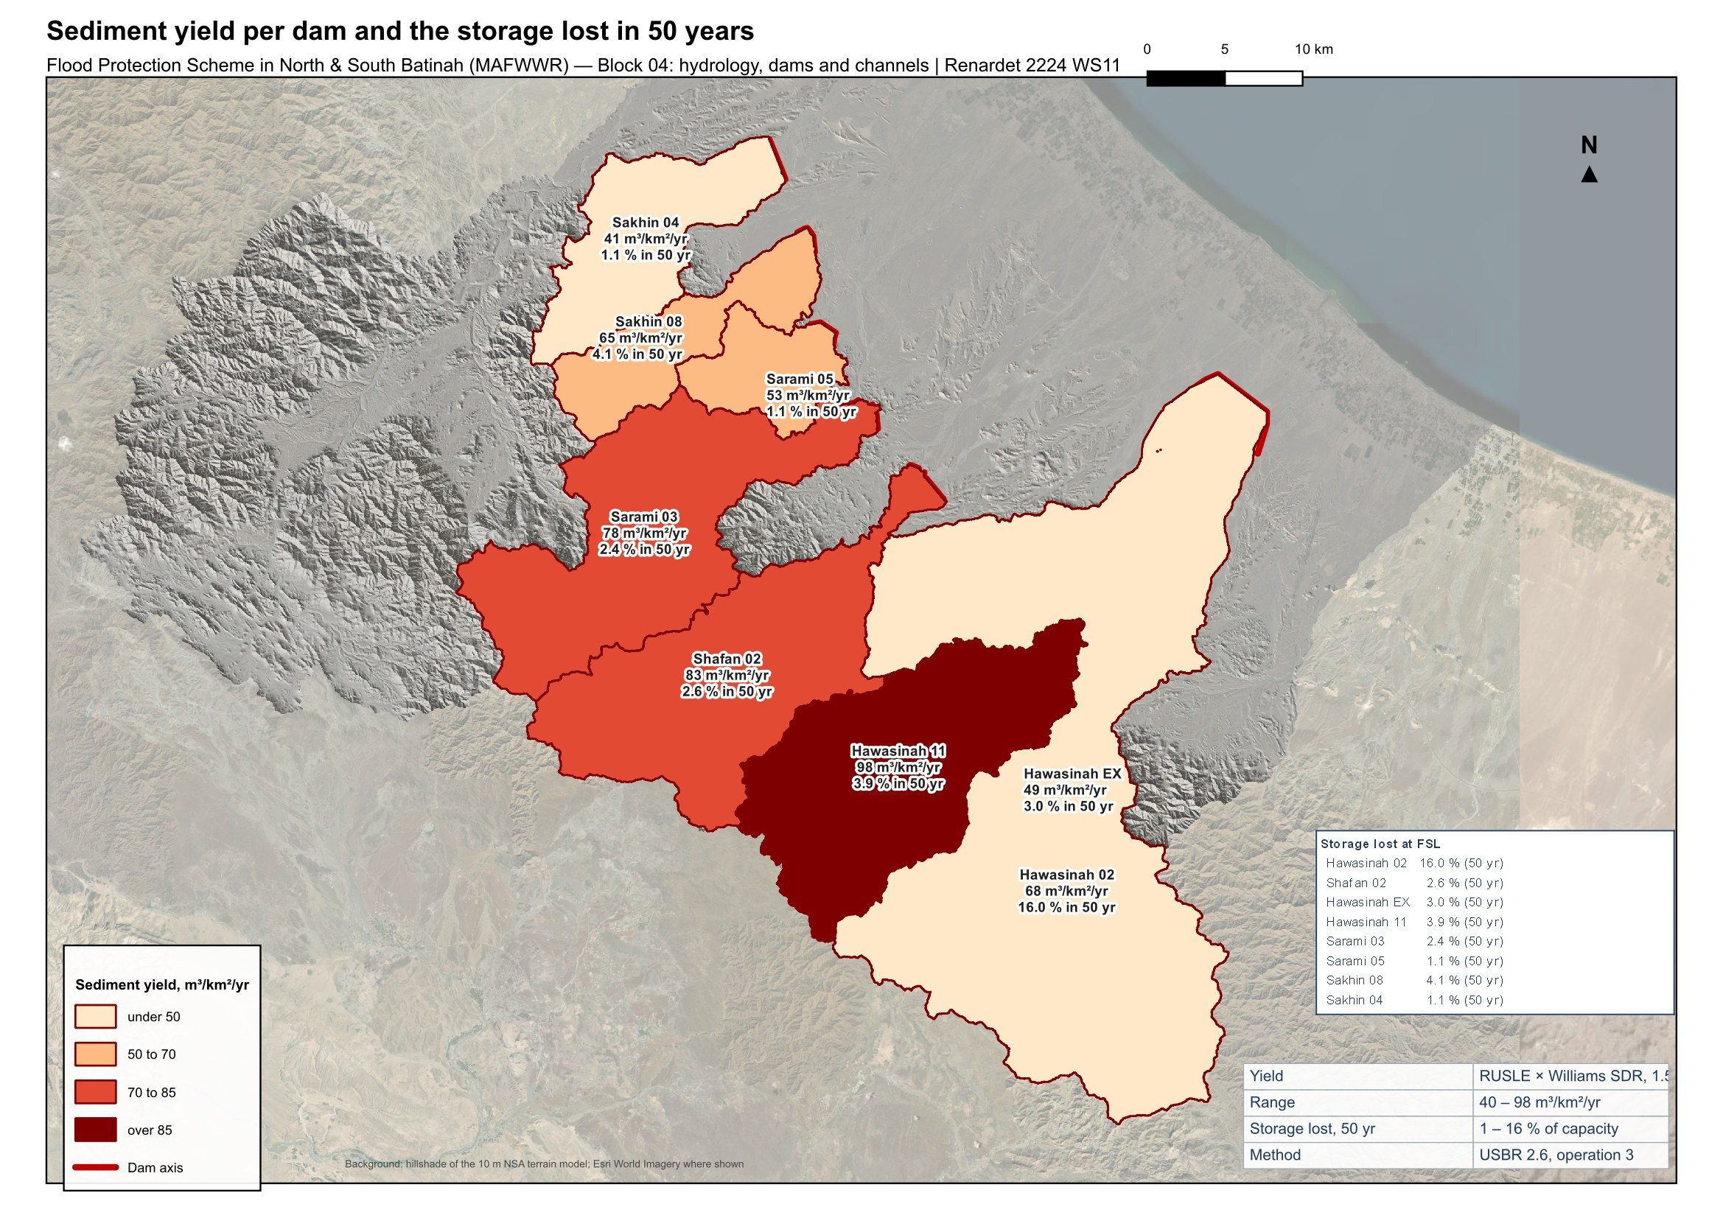
Figure 15. Sediment yield delivered to each dam and the storage lost at full supply level in 50 years.

Reservoir volume reduction
The storage each reservoir loses to the deposited sediment, and its elevation-area-volume curve after 50 and 100 years, follow Section 2.6 of the USBR Erosion and Sedimentation Manual: the sediment trapped over the horizon, the density of the deposit from the texture of the catchment soils, and the distribution of the deposit through the reservoir by the Empirical Area-Reduction Method. The same method and the same validated computation served the Wadi Majlas dam study.
The trap efficiency is taken as 100 %, which is conservative for the storage: a flood-protection reservoir that empties through its outlet passes part of the fine fraction, and Brune's curve would need the mean annual inflow, which is not available. The reservoirs are classified as normally empty (operation 3), so the deposit does not compact with time. Its unit weight follows from the clay, silt and sand fractions of the catchment topsoil:
$W_{1} = 641 p_{c} + 1150 p_{m} + 1550 p_{s}$ (8)
W_1: unit weight of the deposit, operation 3, kg/m³
p_c, p_m, p_s: clay, silt and sand fractions of the incoming sediment, –
The deposit is distributed with depth by the type curve of the reservoir, chosen from the shape factor of its original elevation-capacity curve (type II, flood plain and foothill, for six reservoirs; type III, hill, for Hawasinah 11, Sarami 03 and Sakhin 04). The new zero-capacity elevation at the dam and the revised area and capacity at every 0.5 m are computed from the sediment volume:
$a\left(p\right) = C p^{A} {\left(1 - p\right)}^{B}$ (9)
a(p): relative sediment area at relative depth p, –
p: relative depth above the original bed, 0 at the bed and 1 at FSL, –
C, A, B: coefficients of the reservoir type (II: 2.487, 0.57, 0.41; III: 16.967, 1.15, 2.32), –
Table 12. Reservoir volume reduction after 50 and 100 years
Dam | Capacity at FSL (Mm³) | Deposit density (kg/m³) | Type | Deposit 50 yr (Mm³) | Capacity 50 yr (Mm³) | Loss 50 yr (%) | Bed rise 50 yr (m) | Deposit 100 yr (Mm³) | Capacity 100 yr (Mm³) | Loss 100 yr (%)
Hawasinah 02 | 10.41 | 1,291 | 2 | 1.66 | 8.75 | 16.0 | 2.9 | 3.33 | 7.09 | 31.9
Shafan 02 | 41.61 | 1,294 | 2 | 1.08 | 40.52 | 2.6 | 1.5 | 2.17 | 39.44 | 5.2
Hawasinah EX | 79.22 | 1,301 | 2 | 2.42 | 76.80 | 3.0 | 1.6 | 4.83 | 74.38 | 6.1
Hawasinah 11 | 33.17 | 1,290 | 3 | 1.28 | 31.89 | 3.9 | 0.7 | 2.57 | 30.61 | 7.7
Sarami 03 | 42.70 | 1,295 | 3 | 1.03 | 41.67 | 2.4 | 0.0 | 2.06 | 40.64 | 4.8
Sarami 05 | 14.52 | 1,327 | 2 | 0.16 | 14.36 | 1.1 | 0.0 | 0.32 | 14.20 | 2.2
Sakhin 08 | 7.46 | 1,308 | 2 | 0.30 | 7.16 | 4.1 | 1.6 | 0.61 | 6.85 | 8.2
Sakhin 04 | 22.61 | 1,324 | 3 | 0.25 | 22.35 | 1.1 | 0.0 | 0.51 | 22.10 | 2.2
Seven reservoirs lose 1.1 to 4.1 % of their storage in 50 years and 2.2 to 8.2 % in 100 years, and their beds at the dam rise by less than 3 m. Hawasinah 02 is the exception: 1,663 000 m³ of sediment a year settle in a reservoir of 10.4 Mm³, which loses 16.0 % of its storage in 50 years and 31.9 % in 100. Its flood-routing performance, which already passes the 200-year peak almost unattenuated, degrades further with the lost storage; the dam design should provide for sediment management, a dead storage allowance or periodic removal.
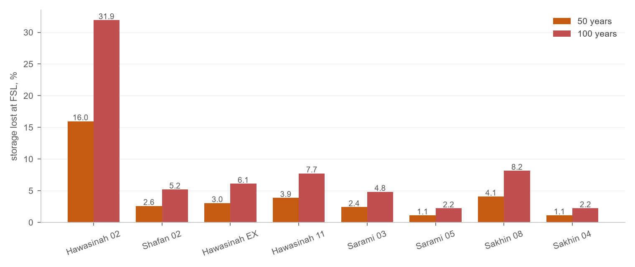
Figure 16. Storage lost at full supply level after 50 and 100 years, per dam.
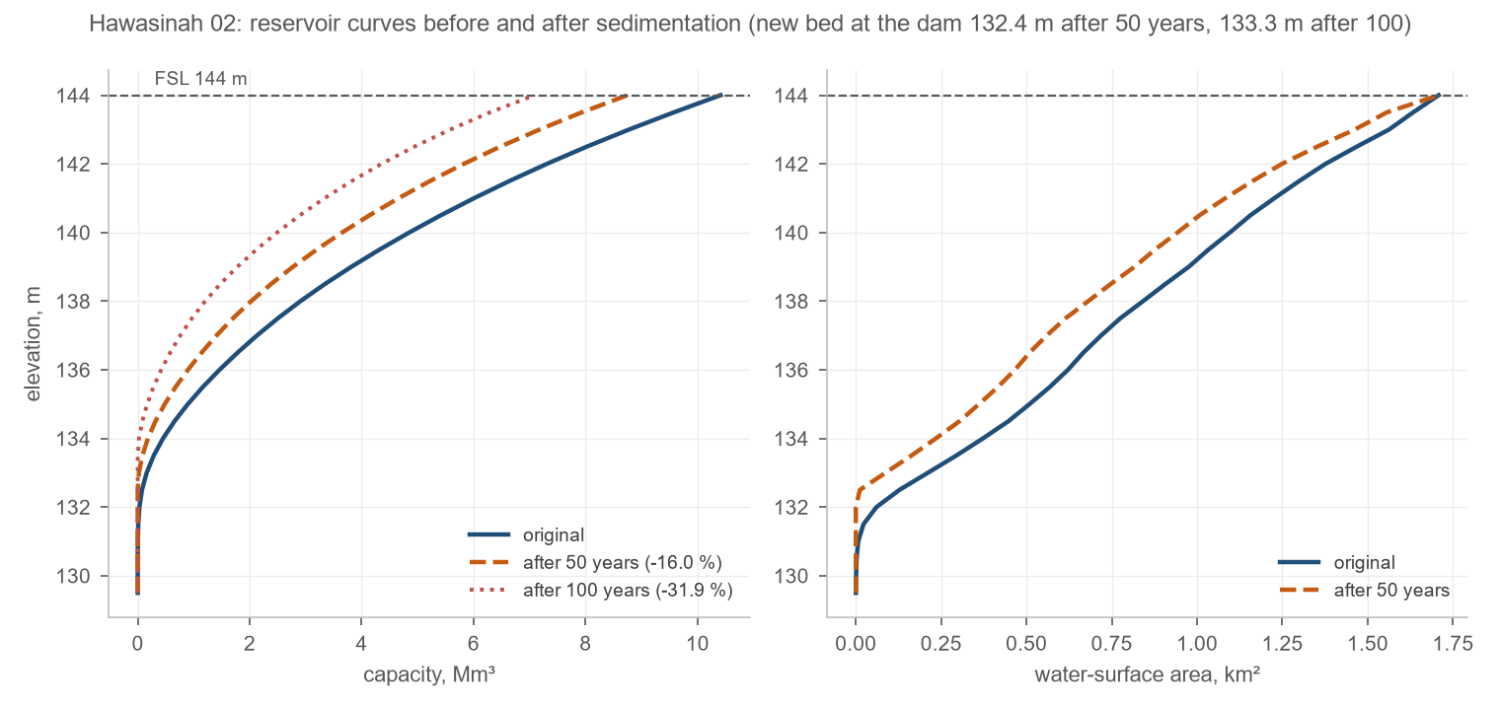
Figure 17. Hawasinah 02: elevation-capacity and elevation-area curves before and after sedimentation. The curves of the other dams are in Appendix B.

Climate at the dam sites

Record used
No station record was available at the dam sites. The figures of this section come from the NASA POWER record, the MERRA-2 reanalysis served on a grid of about 50 km, read at the eight dam sites: daily temperature and rainfall for 2001 to 2023 and hourly wind at 10 m for 2015 to 2024. The eight sites fall in one grid cell, so one record describes the regime at every dam; it does not resolve the difference between the mountain catchments and the plain, which the 1 km rainfall climatology of Section 4 shows (Table 13). The record describes the regime and does not replace the station data the dam design will use.

Temperature and rainfall
The mean annual temperature is 28.5 °C. The hottest month is Jun, with a mean daily maximum of 40.3 °C, and the coolest Jan, with a mean daily minimum of 16.0 °C; the record's extremes are 45.3 and 9.9 °C. The mean annual rainfall is 100 mm, between 44 mm in 2008 and 287 mm in 2017, on 18 wet days a year. Rain falls mostly from November to April (65 % of the total) with a secondary summer peak from the convective storms of July and August; the largest daily total of the record is 77.0 mm on 2020-01-11.
Table 13. Monthly temperature and rainfall at the dam sites, 2001–2023
Month | Mean daily maximum (°C) | Daily mean (°C) | Mean daily minimum (°C) | Rainfall (mm)
Jan | 24.8 | 19.8 | 16.0 | 14.1
Feb | 27.1 | 21.4 | 17.1 | 6.9
Mar | 30.6 | 24.8 | 20.0 | 17.6
Apr | 34.9 | 29.2 | 24.2 | 8.9
May | 39.2 | 33.5 | 28.2 | 5.5
Jun | 40.3 | 35.1 | 30.4 | 4.8
Jul | 39.5 | 34.9 | 31.0 | 9.1
Aug | 38.6 | 33.8 | 30.1 | 6.9
Sep | 37.4 | 32.3 | 28.5 | 4.3
Oct | 34.7 | 29.6 | 25.9 | 4.7
Nov | 30.1 | 25.3 | 21.8 | 7.5
Dec | 26.4 | 21.6 | 18.1 | 9.8
Year | 33.6 | 28.4 | 24.3 | 100
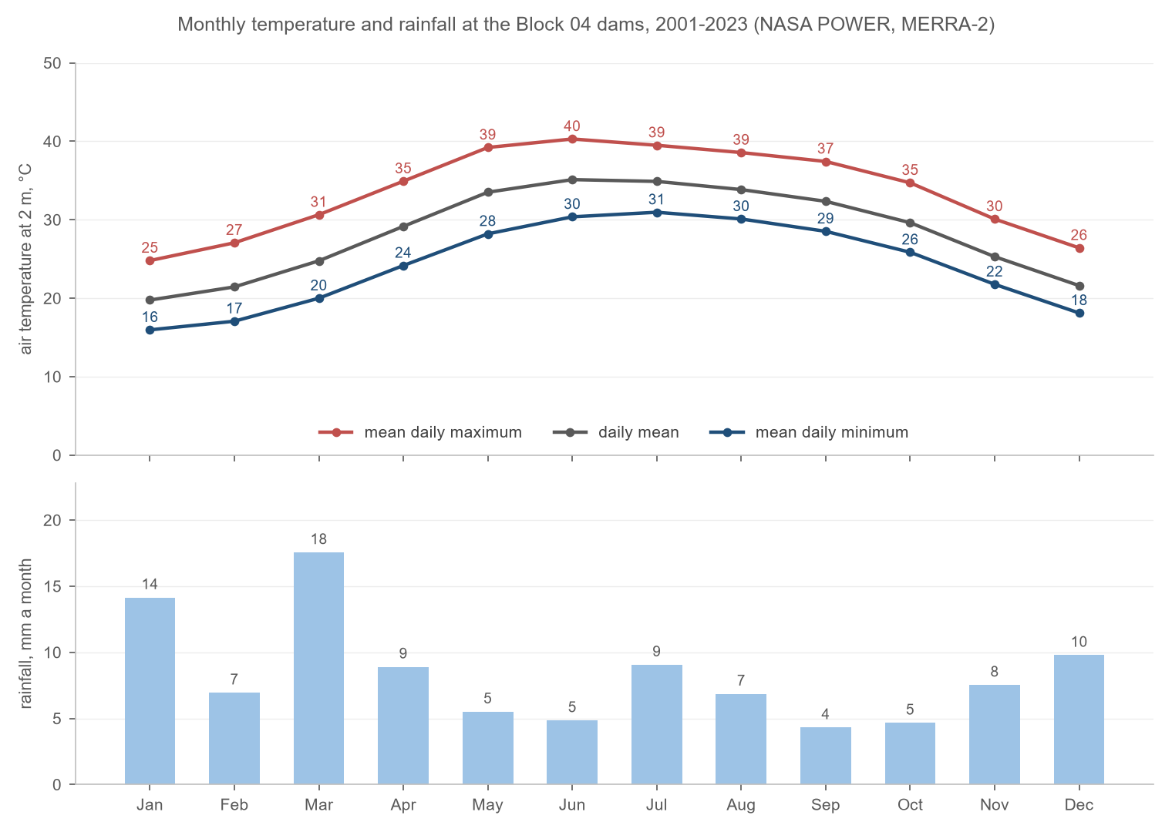
Figure 18. Monthly temperature and rainfall at the Block 04 dams, 2001–2023 (NASA POWER, MERRA-2).
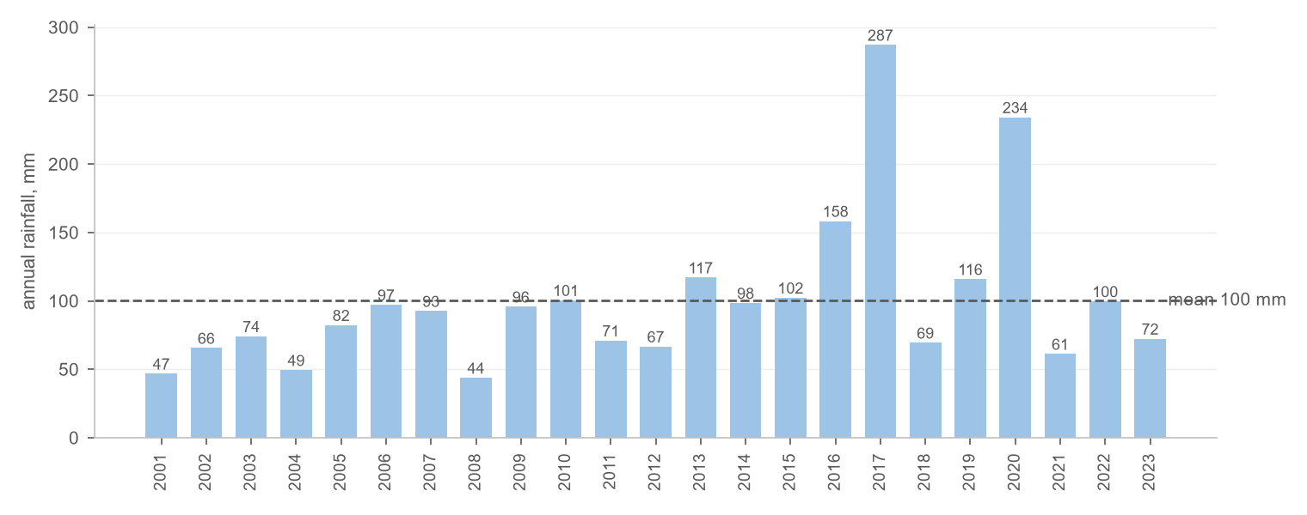
Figure 19. Annual rainfall at the dam sites, 2001–2023, and the mean of the record.
The 1 km rainfall climatology used for the erosivity factor gives the mean annual rainfall of each catchment (Table 13): the mountain catchments receive about half as much again as the coarse grid cell, the plain catchments about the same.
Table 14. Mean annual rainfall of the dam catchments, SM2RAIN climatology 2007–2018
Dam | Catchment mean annual rainfall (mm)
Hawasinah 02 | 140
Shafan 02 | 148
Hawasinah EX | 133
Hawasinah 11 | 147
Sarami 03 | 151
Sarami 05 | 123
Sakhin 08 | 134
Sakhin 04 | 124

Wind
The wind at 10 m averages 3.1 m/s and is calm (below 1 m/s) for 8 % of the hours. It follows the sea breeze: the north-east to east-north-east sector takes 24.0 % of the hours and prevails by day in every season, and the westerly land breeze takes the nights. Speeds above 8 m/s are rare and come from the west and south-west.
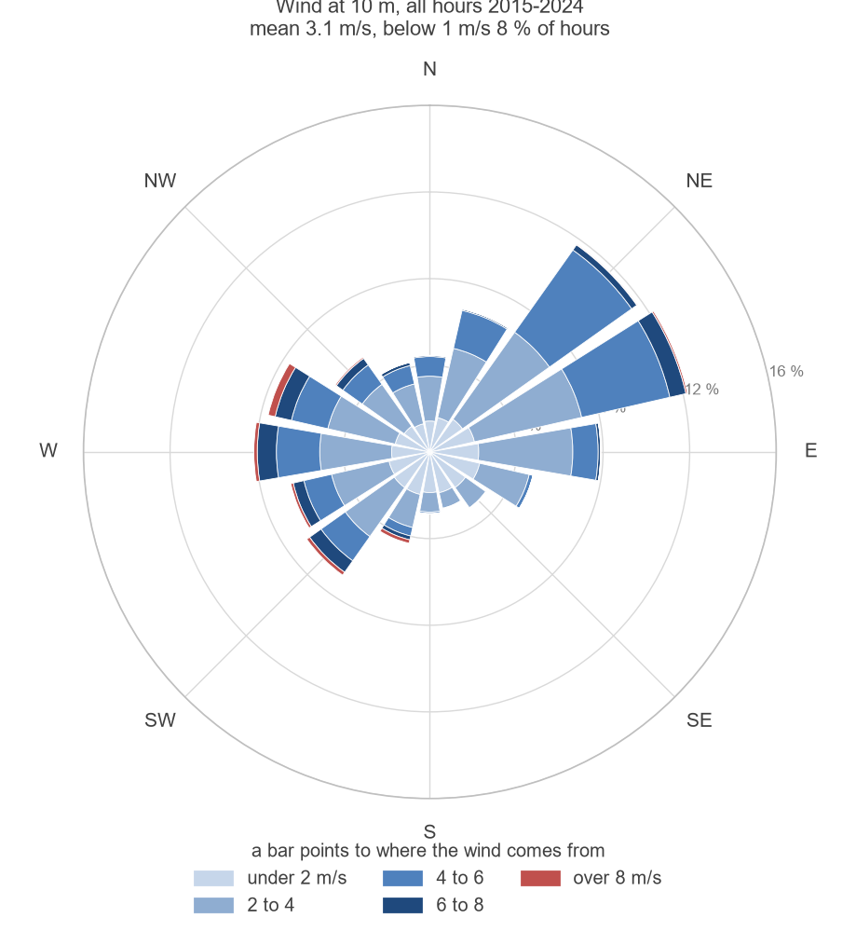
Figure 20. Wind rose at 10 m at the dam sites, all hours 2015–2024: the direction the wind blows from and the share of hours in each speed class.
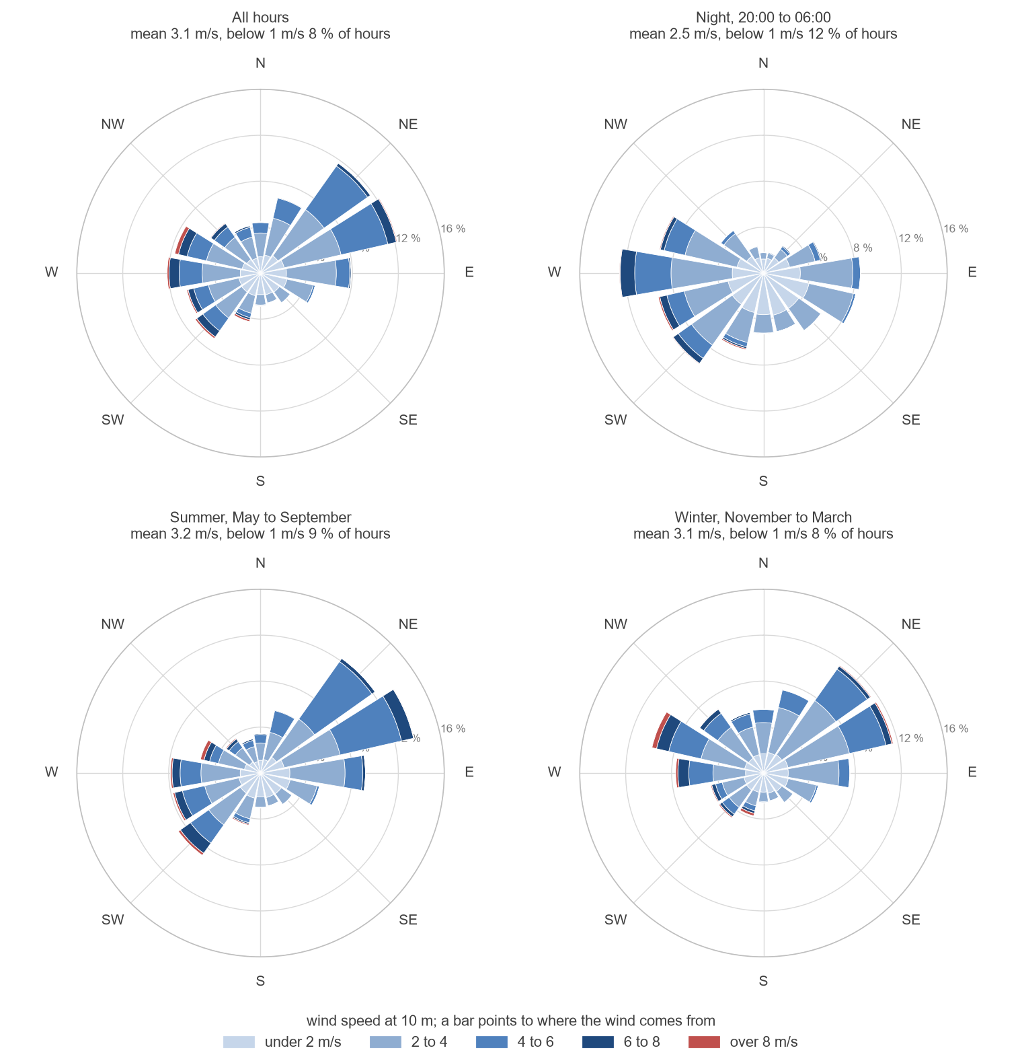
Figure 21. Wind roses for all hours, the night, the summer and the winter.

Climate change
The record itself shows a warming of 0.22 °C per decade over 2001–2023. The Sixth Assessment Report of the IPCC places the Arabian Peninsula among the regions warming faster than the global mean, with more frequent and longer hot spells, and projects for the Gulf of Oman coast a mean annual rainfall that stays low and uncertain in sign while the intensity of the heaviest daily rainfall increases with the warming of the sea and the air. Tropical cyclones of the Arabian Sea, Gonu in 2007 and Shaheen in 2021, have already brought daily totals to the Batinah coast beyond anything in the gauged record.
For the dams this means three things. The design rainfall of the national study, derived from the gauged record, is the floor of the flood load and not its ceiling; the spillway capacity and the 5 m head at the probable maximum flood, which the routing confirms, are the margin against a larger event. Hotter and drier years lengthen the empty periods of the reservoirs and the exposure of their beds, and more intense storms raise the sediment yield above the long-term rate estimated in Section 4, so the storage lost to sedimentation at Hawasinah 02 should be read as a lower bound. The operating rules of the outlets and the freeboard of the downstream channels should be reviewed against the updated rainfall statistics when the national study is revised.

Channels

Alignments and design flows
The channel and dyke alignments of Block 04 are drawn in the CH and WALL layers shown in Figure 2: flood-protection channels from each dam to the sea, medium and small swales across the plain, and dykes where the plain is too flat for a channel to hold the flow. The alignments are tentative until the HEC-RAS 2D results, the wadi geometry and the site visits with the client and the local authorities confirm them, as in Block 6.
The design flows are the routed 200-year flows of Basin 3 at every reach and junction of the model, delivered in the workbooks and the shapefiles of Appendix C. The flood-protection channel below Hawasinah 02 carries the largest flow, 4,049 m³/s, and the channels below the four dams that hold the 200-year flood carry only the runoff of the plain. Across the 115 reaches the 200-year flow runs from nil, below the four dams that hold the flood, to 4,049 m³/s.

Design criteria
The channels are designed in SewerGEMS with the criteria of Block 6: trapezoidal earth channels with side slopes of 1:1.5, a depth of 2.5 m or the depth of the existing wadi where it is deeper, a Manning n of 0.03 for earth channels and 0.02 for concrete culverts, a maximum velocity of 3 m/s, a minimum slope of 0.0003 at the sea outfalls, a freeboard of 0.6 m, and bank levels at the outfalls set above the mean higher high water of the Oman Maritime Book. Cut sections are preferred so that the runoff of the plain drains into the channel; a fill section returns to cut within 500 m.

Status
The hydraulic design of the channels, the dyke heights from the HEC-RAS 2D simulation, the capacity check of the existing culverts and bridges on the Batinah Expressway, the Batinah Highway and the coastal road, and the channel inventory and quantities are reported in the next revision.

Conclusions
The HEC-HMS model of Block 04 reproduces the dam catchments of the hydrology study and extends them to the whole plain: 110 subbasins, 115 reaches, 129 junctions and the eight reservoirs, computed as depth-area analyses for thirteen return periods. The dam inflows at the probable maximum precipitation match the design floods of the dams sheet to within 0.3 %.
Four of the eight reservoirs hold the whole 200-year flood and two more pass only a fraction of it; Hawasinah 02 is the exception, with 2 % attenuation. At the probable maximum flood the reservoirs rise 4.7 to 5.0 m above full supply level, within the 5 m head of the dam designs.
The catchments deliver 40 to 98 m³ of sediment per square kilometre and year. Seven reservoirs lose 1.1 to 4.1 % of their storage in 50 years; Hawasinah 02 loses 16 %, and its design should provide for sediment management or additional storage.
The channel design proceeds on the alignments of the CH and WALL layers with the routed 200-year outflows of Basin 3 as the design flows; its results are reported in the next revision.

Appendix A – Inflow hydrographs of the dams
Inflow hydrographs of the thirteen depth-area analyses at each dam, with the peak flow and the volume of every event. The 5-minute series are delivered in the hydrograph workbook.
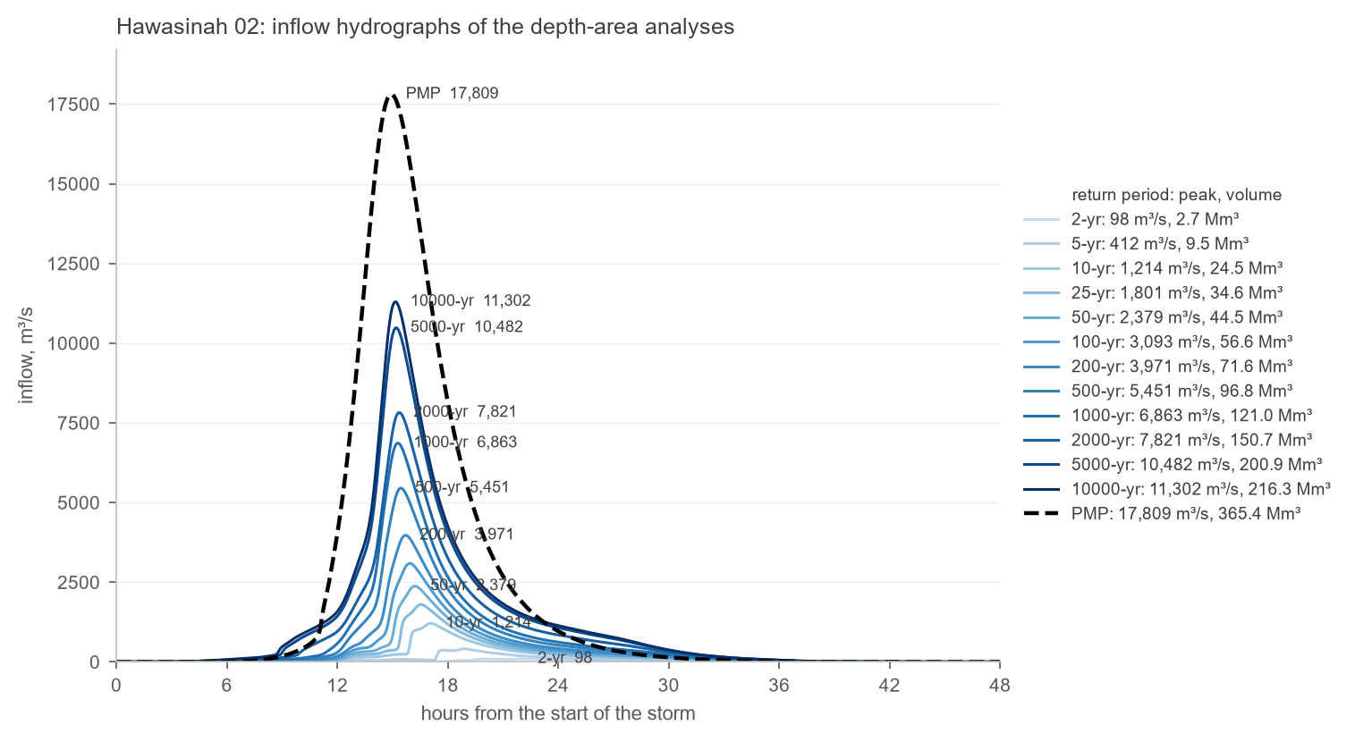
Figure 22. Hawasinah 02: inflow hydrographs for the return periods of 2 to 10 000 years and the PMP.
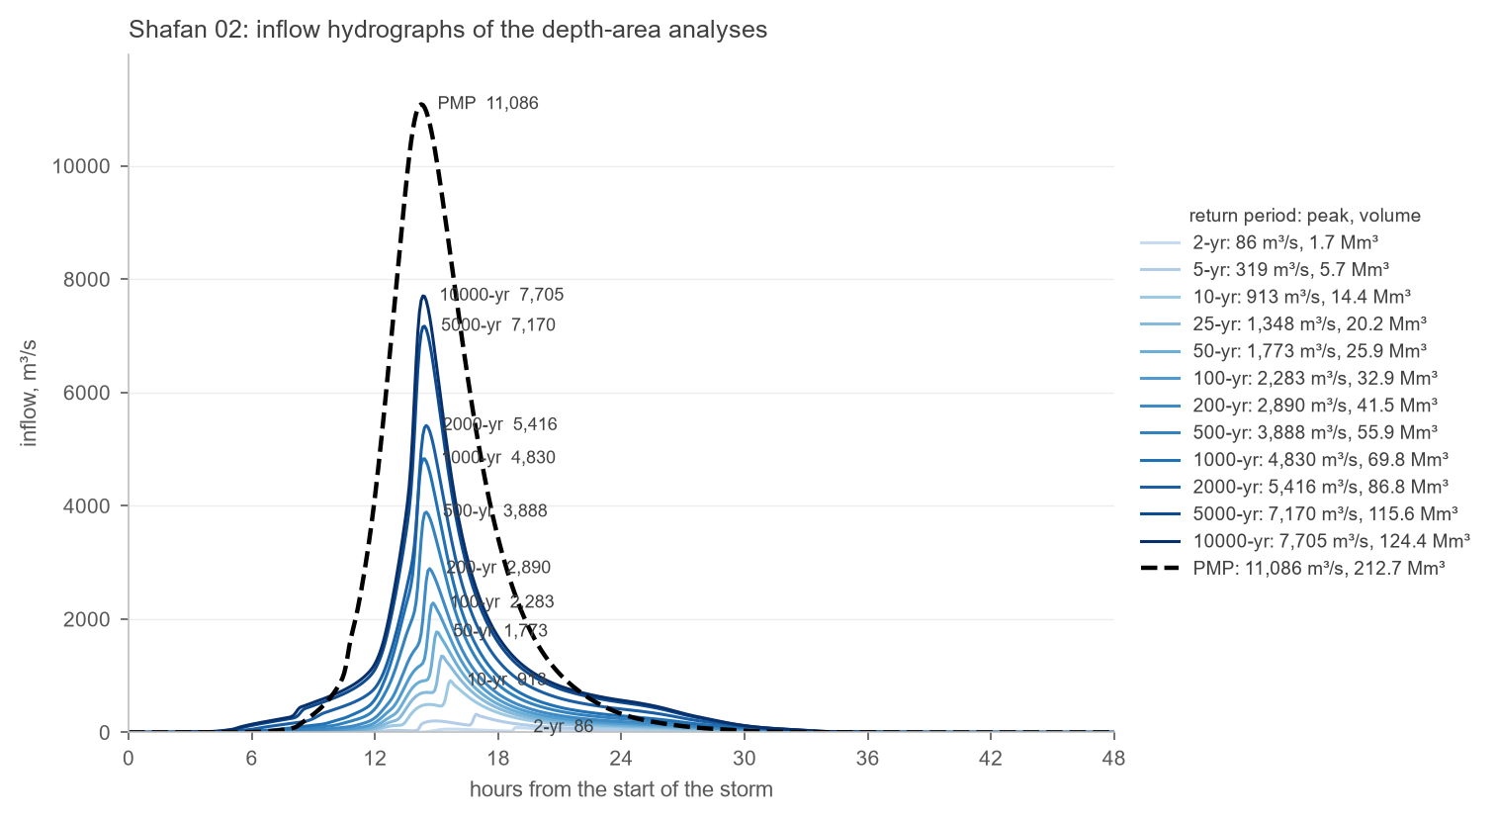
Figure 23. Shafan 02: inflow hydrographs for the return periods of 2 to 10 000 years and the PMP.
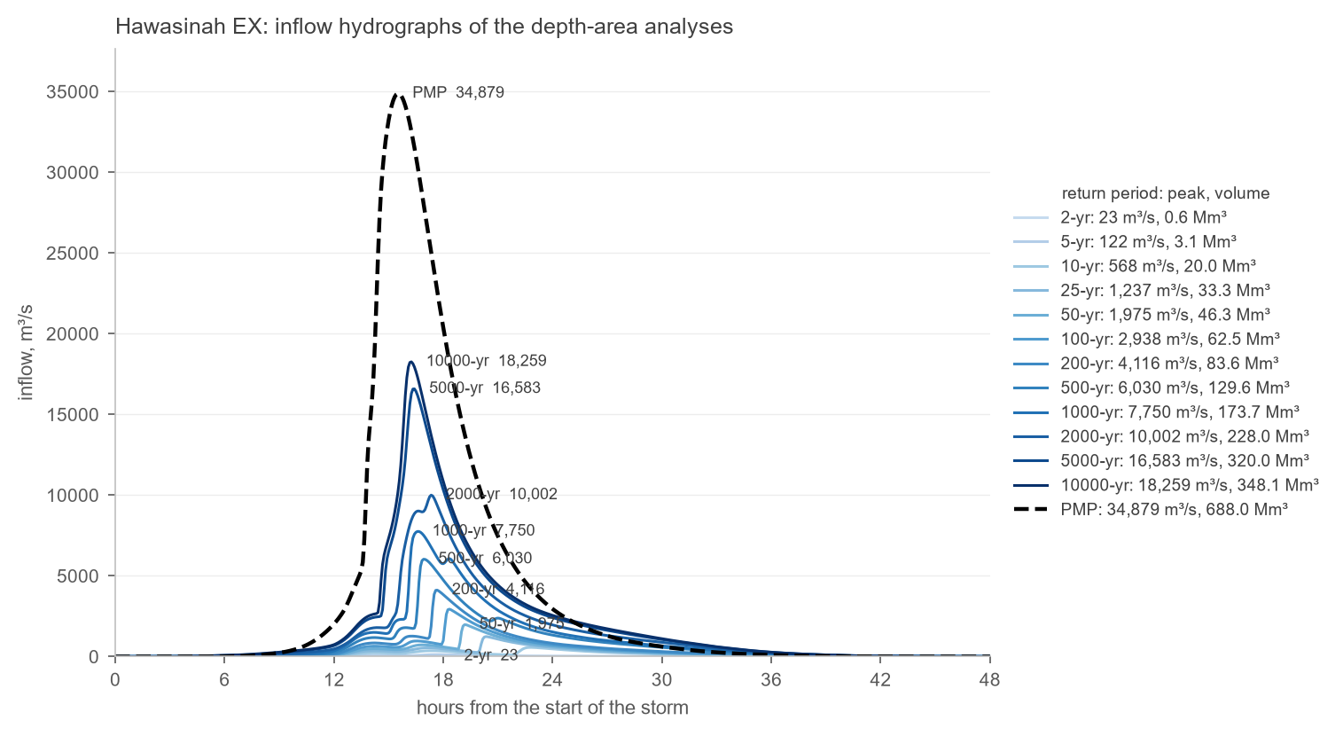
Figure 24. Hawasinah EX: inflow hydrographs for the return periods of 2 to 10 000 years and the PMP.
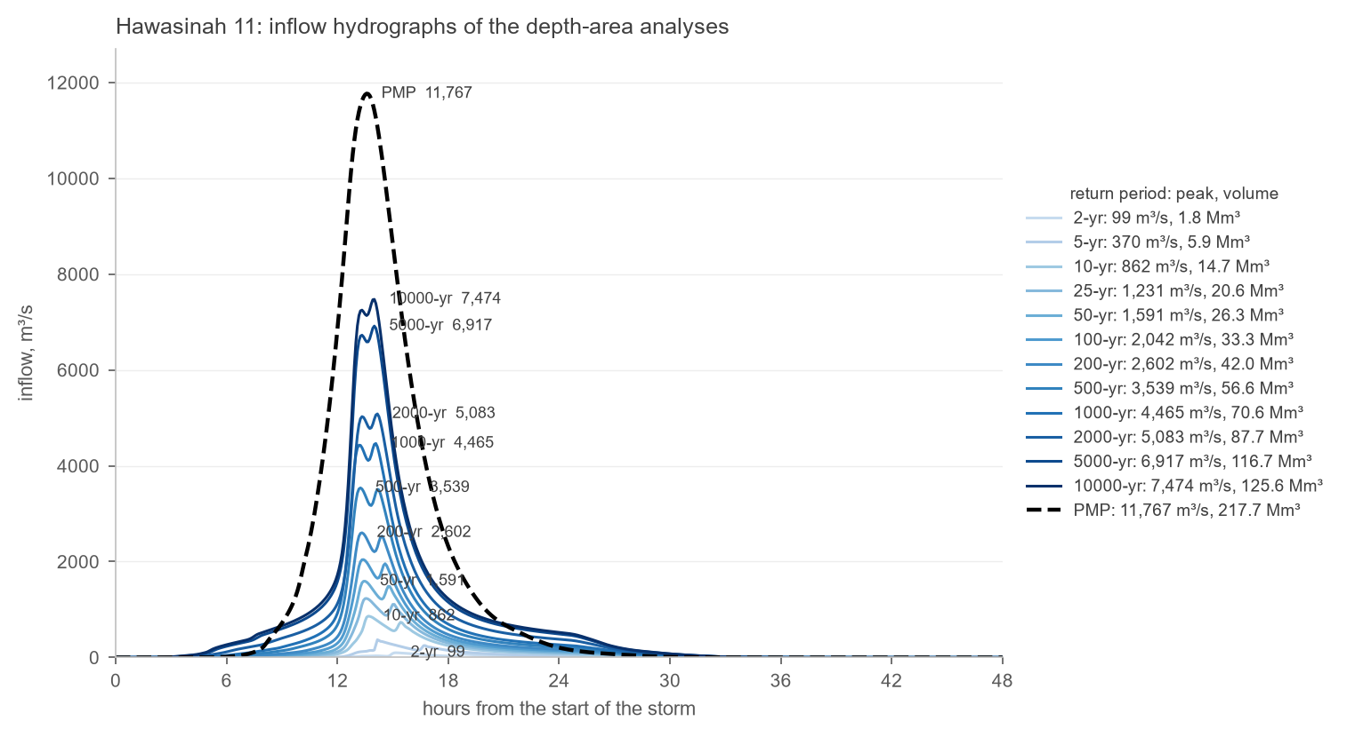
Figure 25. Hawasinah 11: inflow hydrographs for the return periods of 2 to 10 000 years and the PMP.
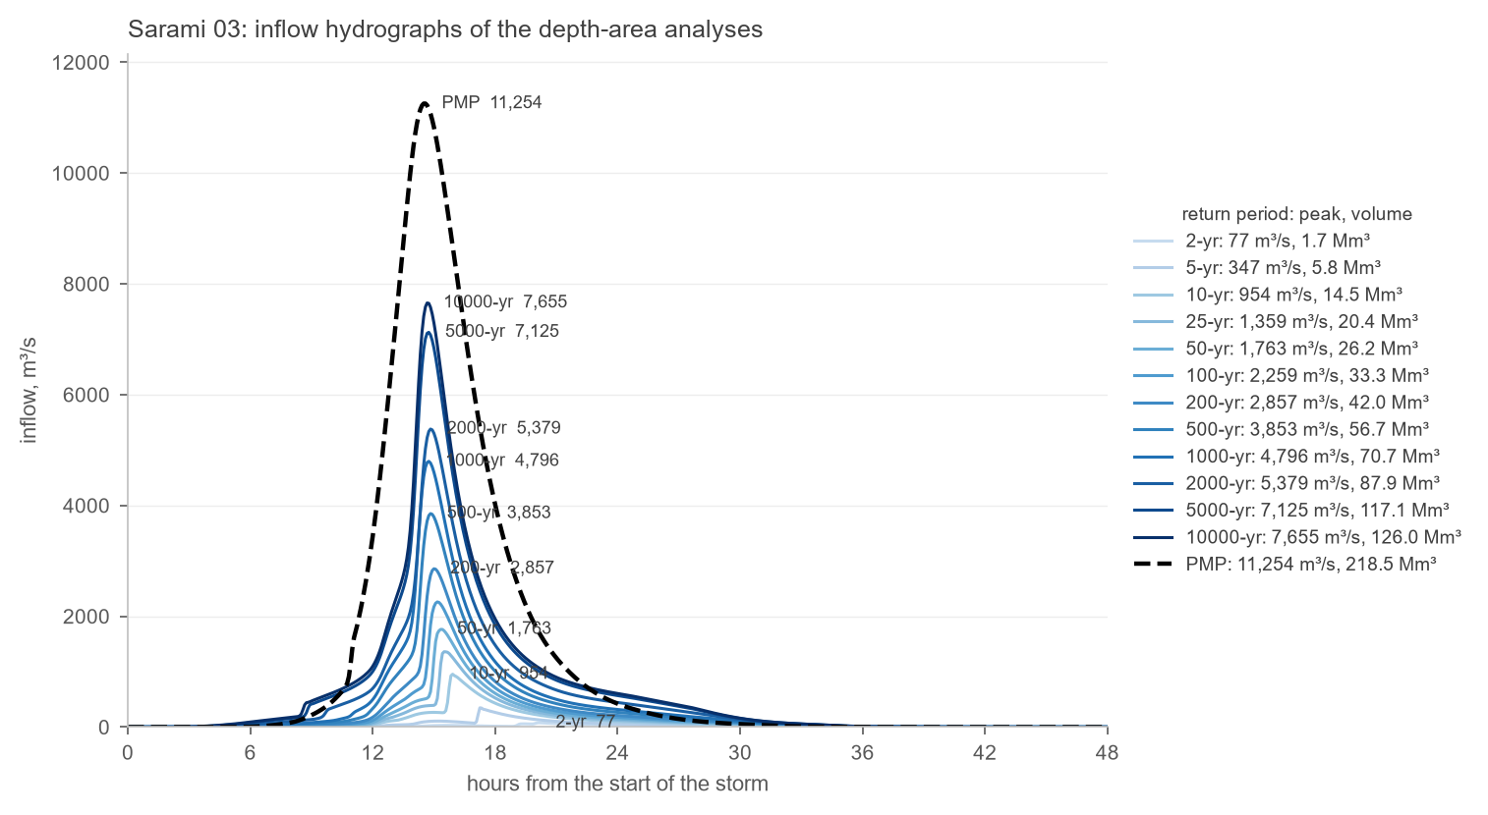
Figure 26. Sarami 03: inflow hydrographs for the return periods of 2 to 10 000 years and the PMP.
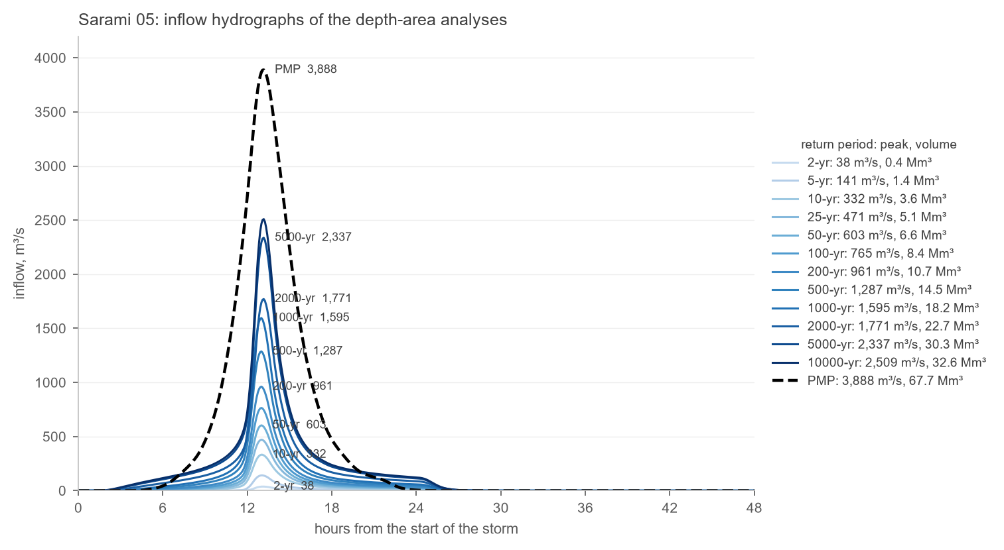
Figure 27. Sarami 05: inflow hydrographs for the return periods of 2 to 10 000 years and the PMP.
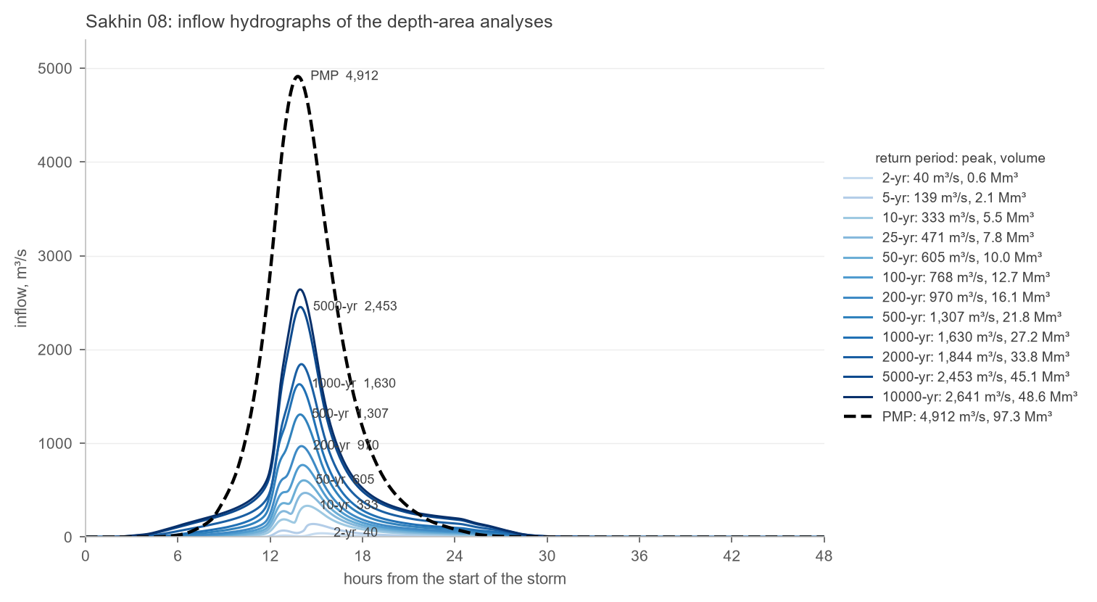
Figure 28. Sakhin 08: inflow hydrographs for the return periods of 2 to 10 000 years and the PMP.
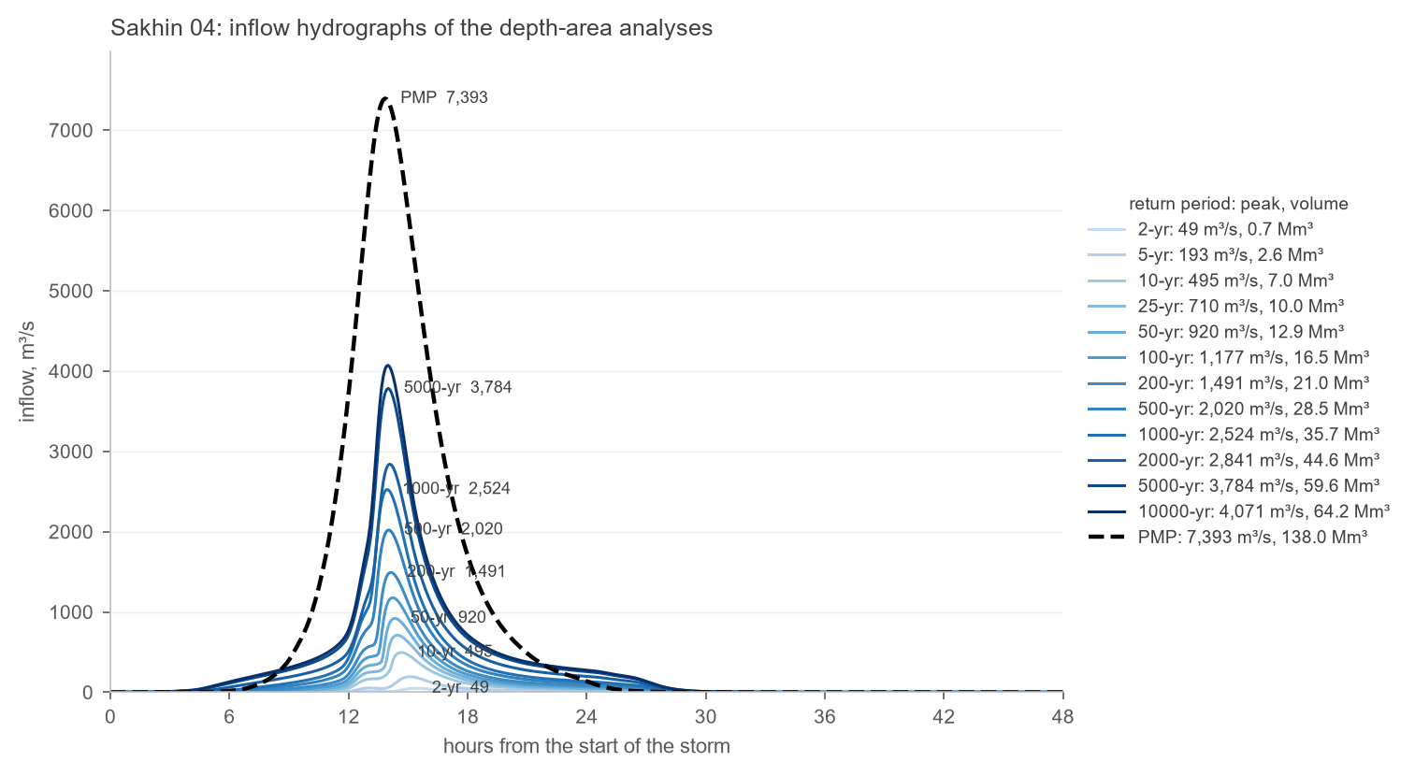
Figure 29. Sakhin 04: inflow hydrographs for the return periods of 2 to 10 000 years and the PMP.

Appendix B – Reservoir curves after sedimentation
Original and revised elevation-capacity and elevation-area curves of each reservoir after 50 and 100 years of sedimentation (Section 4.3). The tables at 0.5 m steps are in the sedimentation workbook.
Figure 30. Hawasinah 02: reservoir curves before and after sedimentation.
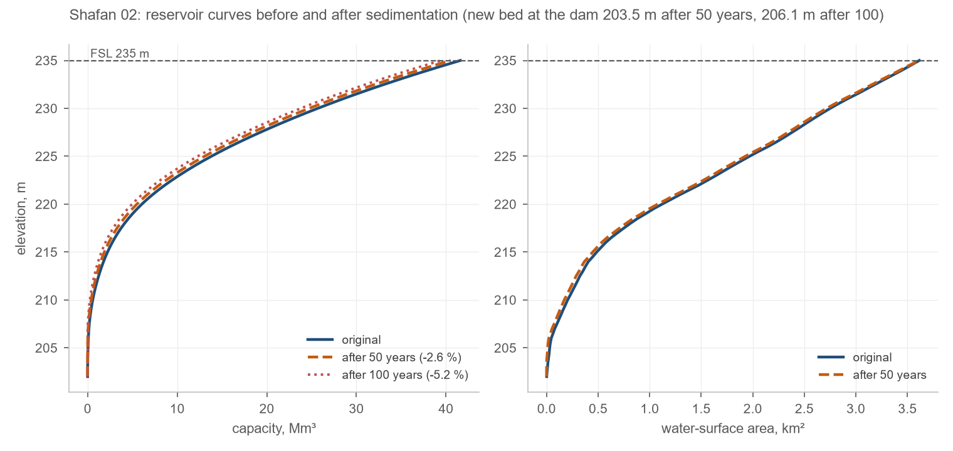
Figure 31. Shafan 02: reservoir curves before and after sedimentation.
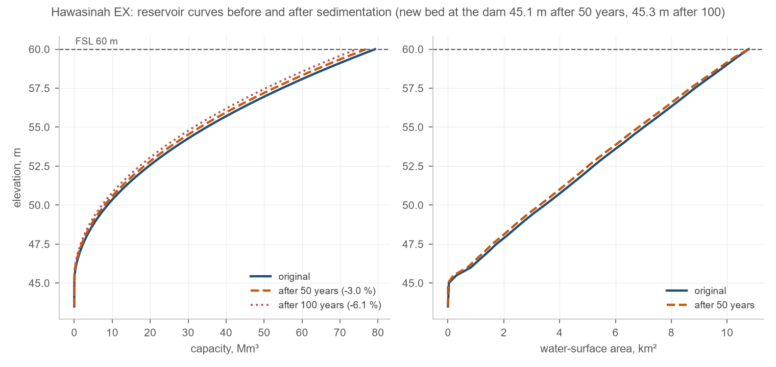
Figure 32. Hawasinah EX: reservoir curves before and after sedimentation.
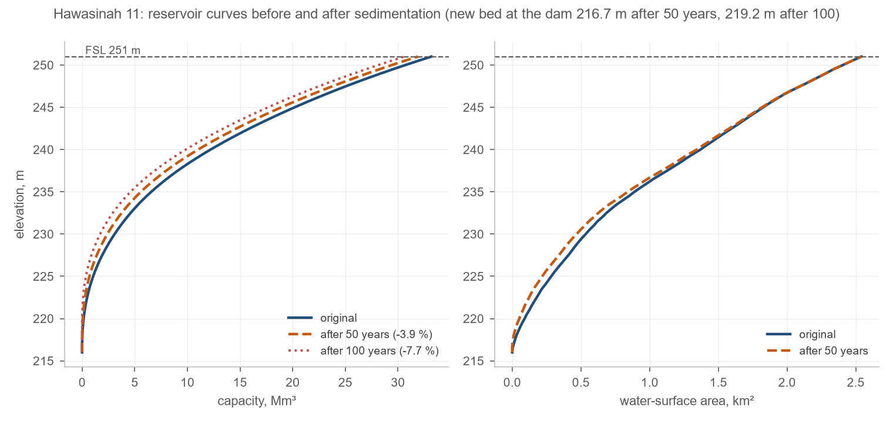
Figure 33. Hawasinah 11: reservoir curves before and after sedimentation.
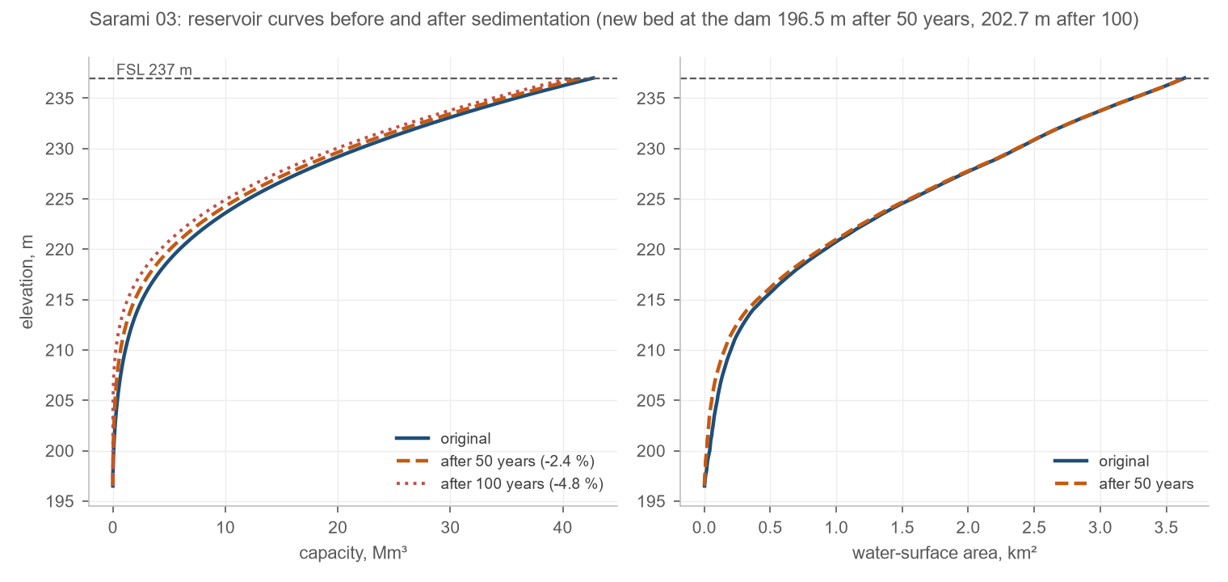
Figure 34. Sarami 03: reservoir curves before and after sedimentation.
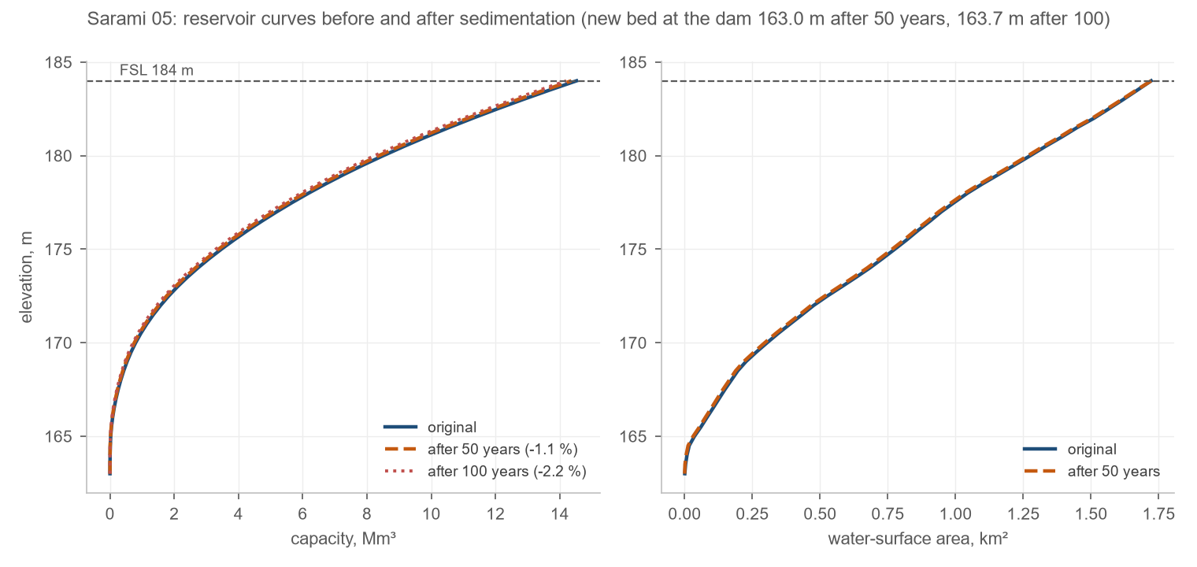
Figure 35. Sarami 05: reservoir curves before and after sedimentation.
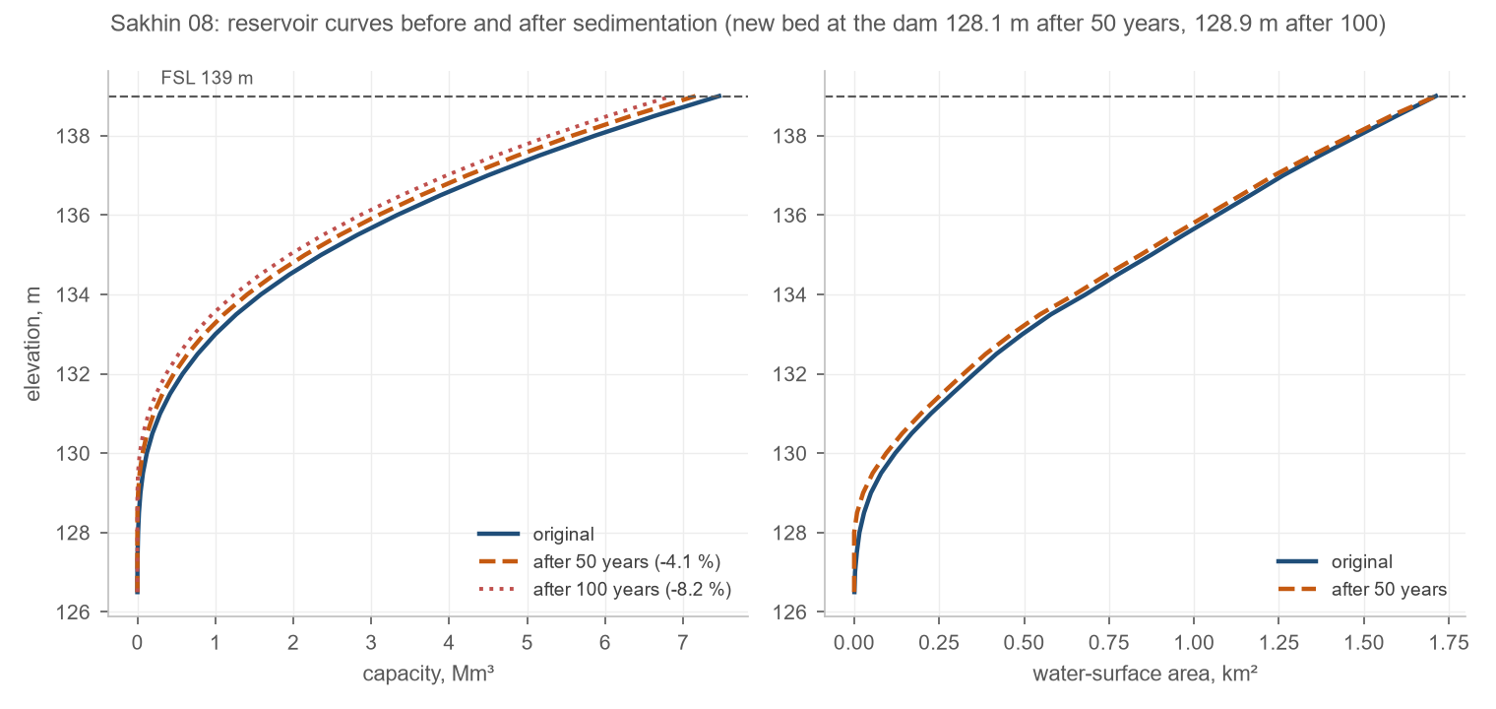
Figure 36. Sakhin 08: reservoir curves before and after sedimentation.
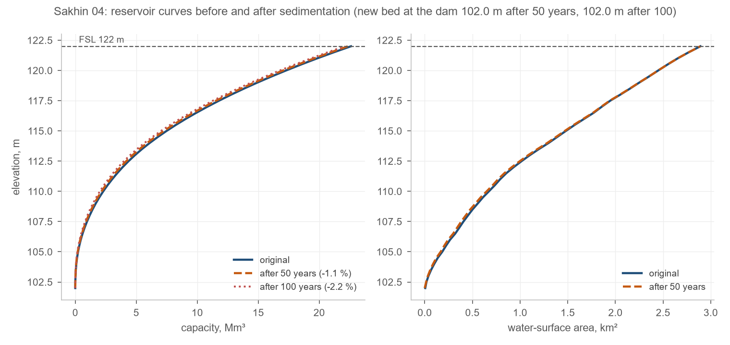
Figure 37. Sakhin 04: reservoir curves before and after sedimentation.

Appendix C – Digital deliverables
The following files accompany this report (folder Claude Block 04/W3). Every workbook carries its formulas and recalculates when an input changes.
Table 15. Digital deliverables
File | Content
dams/eav/Block04_Dams_Elevation_Area_Volume.xlsx | Dams sheet and one sheet per dam: elevation, area, conic volume at 0.5 m, charts with FSL and crest
dams/hydrographs/Block04_Dam_Hydrographs.xlsx | One sheet per dam: 5-minute inflow and outflow for the 13 return periods, statistics, all-inflow and per-event charts; summary sheets
dams/hydrographs/dams_reservoirs.xlsx | Hydrographs, peak inflow/outflow and volumes in the Block 6 layout; peak levels and attenuation
elements/xlsx/peak_flow_volume_all_elements_B3.xlsx, _B2.xlsx | Peak flow and volume of every element of Basin 3 (with the reservoirs) and Basin 2 (without), 13 return periods
elements/shp/B3, B2 and Block04_elements_B3.gpkg, _B2.gpkg | Subbasins, reaches and points with the HMS parameters and Q and V of every return period
elements/kmz/B3, B2 | 28 KMZ files each: all layers, basins and reaches with their tables, Q and V of every return period at the points
sediment/catchments/Dam_catchments.shp, .gpkg | The eight dam catchments
sediment/B4_DAM_RUSLE.xlsx | RUSLE factors, soil loss, relief ratio, Williams SDR and sediment yield
sediment/Block04_Reservoir_Sedimentation.xlsx | USBR 2.6 reservoir volume reduction, 50 and 100 years, revised curves per dam
sediment/rusle/Output | RUSLE rasters (R, K, LS, C, P, soil loss) and the pipeline's maps
climate/Block04_Climate.xlsx | Daily record, monthly and annual statistics, wind sector table, wind rose, catchment rainfall
maps/Block04_W3_maps.qgz, maps/png | QGIS project with the layouts of every map figure and the exported figures

MAFWR, nationwide hydrology study: regional frequency analysis of the 24-hour rainfall, design patterns and the PMP grid; the same inputs as the Block 6 channel design report (April 2026).
W3/dams/eav/Block04_Dams_Elevation_Area_Volume.xlsx: one sheet per dam, 0.5 m steps, areas from the DEM, conic volumes, charts with the FSL and the crest.
Renard, K.G. et al. (1997), Predicting soil erosion by water: a guide to conservation planning with the Revised Universal Soil Loss Equation (RUSLE), USDA Agriculture Handbook 703. Pipeline: github.com/mojikone/RUSLE, run on the eight catchments on 2026-10-06.
Williams, J.R. (1977), Sediment delivery ratios determined with sediment and runoff models, IAHS Publication 122. The delivered mass is converted to a volume at 1.5 t/m³, the Block 6 convention; the reservoir study of section 4.3 re-expresses it at the deposited density.
U.S. Bureau of Reclamation (2006), Erosion and Sedimentation Manual, Chapter 2, Section 2.6: trap efficiency (2.6.1), density of deposited sediment (2.6.2, Lara and Pemberton 1965; Miller 1953), sediment distribution (2.6.3, Borland and Miller 1960; Lara 1962).
NASA Prediction Of Worldwide Energy Resources (POWER), MERRA-2 reanalysis, power.larc.nasa.gov, read in October 2026 at the dam junction coordinates. 2024 excluded from the daily record: August 2024 carries 1 312 mm (272.8 mm on 18 August), an artefact of the near-real-time POWER precipitation stream.
IPCC (2021), Climate Change 2021: The Physical Science Basis, Sixth Assessment Report, Working Group I, Chapter 11 (weather and climate extreme events) and Atlas, regional findings for the Arabian Peninsula.

